# Introduction

The problem I am going to undertake is to design and produce a functioning prototype for an orthographic assistance program that my intended client would want to purchase. A typical client would be an adult working in the education sector, to be used by an infant (between 4 and 8 years) learning to spell, but could extend to anyone in need of orthographic assistance. Specifically, I will be referring to Deborah, a 45-year-old childminder who is responsible for the educational development of infants, in order to receive feedback during development.

# Identifying the problem

**3.1.1 Problem identification**

**(a) Describe and justify the features that make the problem solvable by computational methods.**

There are several products currently on the market that offer a solution to such a problem, including Nessy and Grammarly. Listed below are common features in these programs, whose development required a computational solution:

* Adherence to the Orton-Gillingham approach of learning, meaning that each child receives an instruction tailored to their specific learning needs. This would involve numerous calculations in reference to a large data set of personal records, which would outline a specific child’s specific needs. A computer provides the necessary data storage for this task. Such an amount of data would also be next to impossible for a human to interpret, let alone apply in quick succession to make the program appear seamless at run-time. The application of data would need to be consistently accurate, making it impractical to perform without the use of a computer.
* A large word bank of at least 1,000 unique words of varying difficulty, which can be quickly accessed and tested on. A computational solution provides the storage necessary for such a data set, and could be easily adapted/changed to suit the client’s needs. A human would struggle to recall a large amount of unique words for a child to learn, lending this problem to computers. Words could be graded on their learning difficulty and then outputted accordingly, requiring several calculations in a short amount of time. A computational solution also provides a much higher level of accuracy than a human, which is crucial for orthography.
* Constant accessibility to orthographic development, irrespective of the time of day. This allows children to improve their spelling on a consistent basis, and such consistency has been proven to be a more effective way of learning, especially if resources can be accessed quickly. A human cannot provide this level of accessibility due to their own personal commitments. A computer can be ready to provide this service at any time with a high level of reliability, in the form of several portable devices, if the client requires.
* Auditory assistance in orthographic development. Modern speech API’s are able to successfully mimic the human voice with a high level of accuracy. Humans tend to sound more natural, especially to a child’s ear, but computational methods are just as understandable, and offer unmatched reliability and accuracy.
* The ability to provide orthographic development to multiple children/users simultaneously. To provide such a tailored experience to each child would require an equal amount of skilled teachers to give their entire attention. This kind of human application would be costly and inefficient. A computational solution could offer the same level of attention to any number of children/users simultaneously on different machines.

**(b) Explain why the problem is amenable to a computational approach.**

I have therefore decided to computerise my solution for the following reasons:

* Similar systems currently in place show that the problem lends itself to a computational solution.
* My problem will require multiple calculations within a short amount of time, such that it would be problematic to solve in any way other than using a computer.
* There will be a regular need to process large quantities of data, whether it be words to spell or personal records of development. This can be achieved quickly and efficiently by a computer.
* The auditory aspect of my solution would require accessing data from an open speech API. The easiest way to achieve this is to make a request for output from a computer.

# Stakeholders

**3.1.2 Stakeholders**

**(a) Identify and describe those who will have an interest in the solution explaining how the solution is appropriate to their needs (this may be named individuals, groups or persona that describes the target end user).**

The two primary stakeholders are myself and those who work in the education sector, because both seek to benefit from the solution. I am going to use Deborah, a 45-year-old Childminder, as a sample of a potential user of the program, in order to get their feedback on my solution. They will aid in the project development through their feedback as well as assisting in the whole system testing. Once the solution is fully developed, it will be implemented into their employment, so they will intend to improve their business from this program. I could seek to have a financial gain from my product, should it be successful, although the primary focus is to fulfil its function in assisting young children. I will also gain experience in software development through the creation of this solution. The product will eventually be implemented into a real-life scenario.

The users will want the program to be educational and useful, while also remaining fun and engaging, making the product worth their money should it be taken to market. They would want to know that the software is safe to install on their machines, and for the software to be as compact as possible, to minimise the impact on storage space. They would expect a functional product. My solution will fulfil a genuine problem of teaching children how to spell.

# Research of Existing Systems

**3.1.3 Research the problem**

**(a) Research the problem and solutions to similar problems to identify and justify suitable approaches to a solution.**

In order to better understand the problem and be able to make justifiable decisions when designing the solution, research of some of the current systems was conducted. The form of solution, development cycle and issues associated with the solution were all taken into account. This will allow me to learn from the experience of others, and avoid potential issues by considering them beforehand.

# System 1: Memrise

Development studio: Memrise, Inc

Initial release: September 2010

Release price: Freemium (£3.75/month)

Platforms: Web, iOS, Android

Type: Web-based user-generated learning platform which uses flashcards as memory aids

Alexa rank (website traffic): 3,600 (Oct 2018)

Memrise is a user-generated learning platform which uses flashcards as memory aids. It is primarily advertised as language learning software, but also offers content on a wide range of other subjects. Since the basis of this system is a flashcard slideshow, the content covered varies massively from Electronics to Country Flags, for example. Users can submit their own ‘courses’ on whatever topic they choose and can similarly play any other user-made courses over the internet. The presented flashcards prompt the user to remember the word and its meaning, and then tests the user on their knowledge of the word over an extensive period of time. In this way, this system provides orthographic assistance, although it is not specifically advertised in this way.  
  
Memrise first started as a website, connecting thousands of users together to share knowledge of certain topics and gain knowledge of others. The source of knowledge is crowd-funded through this connectivity, requiring no effort from the development studio to create any content themselves, although they choose to provide courses which have guaranteed accuracy. Since the beginning, the website and whole system has amassed more than 150 language courses across 25 languages. The website was later ported to a mobile application, which has over 10,000,000+ downloads on the Google Play Store (as of Oct 2018). The comparative Alexa rank of 3,600 represents the huge popularity of this system, being used as an educational learning device in thousands of schools across the world.

Figure 1

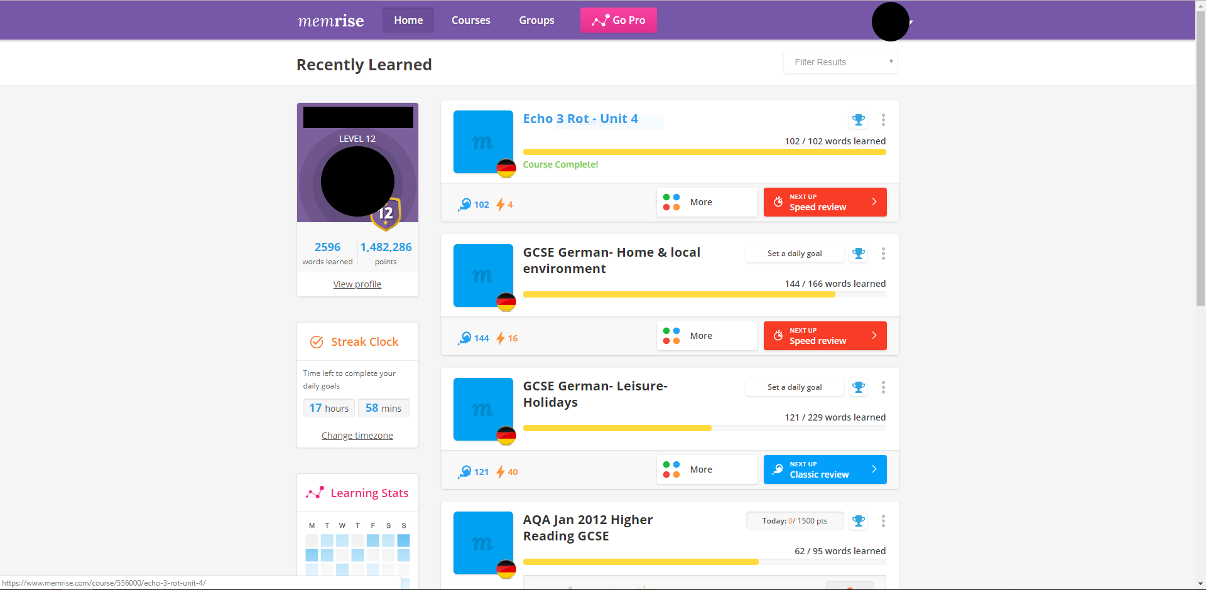

Figure 1 shows the main ‘menu’ which the typical user would see once they login to their account. This menu previews all the courses the user has recently played, as well as their score for each and navigation buttons to view more info. This interface offers a glance at the users’ progress without cluttering the screen with too much information. My solution would seek to improve from a simple interface. A brief summary of the user’s history is also represented through a level, amount of words learnt and number of points gathered. Most site navigation begins from this centred home screen/menu, which is easy for a new user to understand.

Figure 2

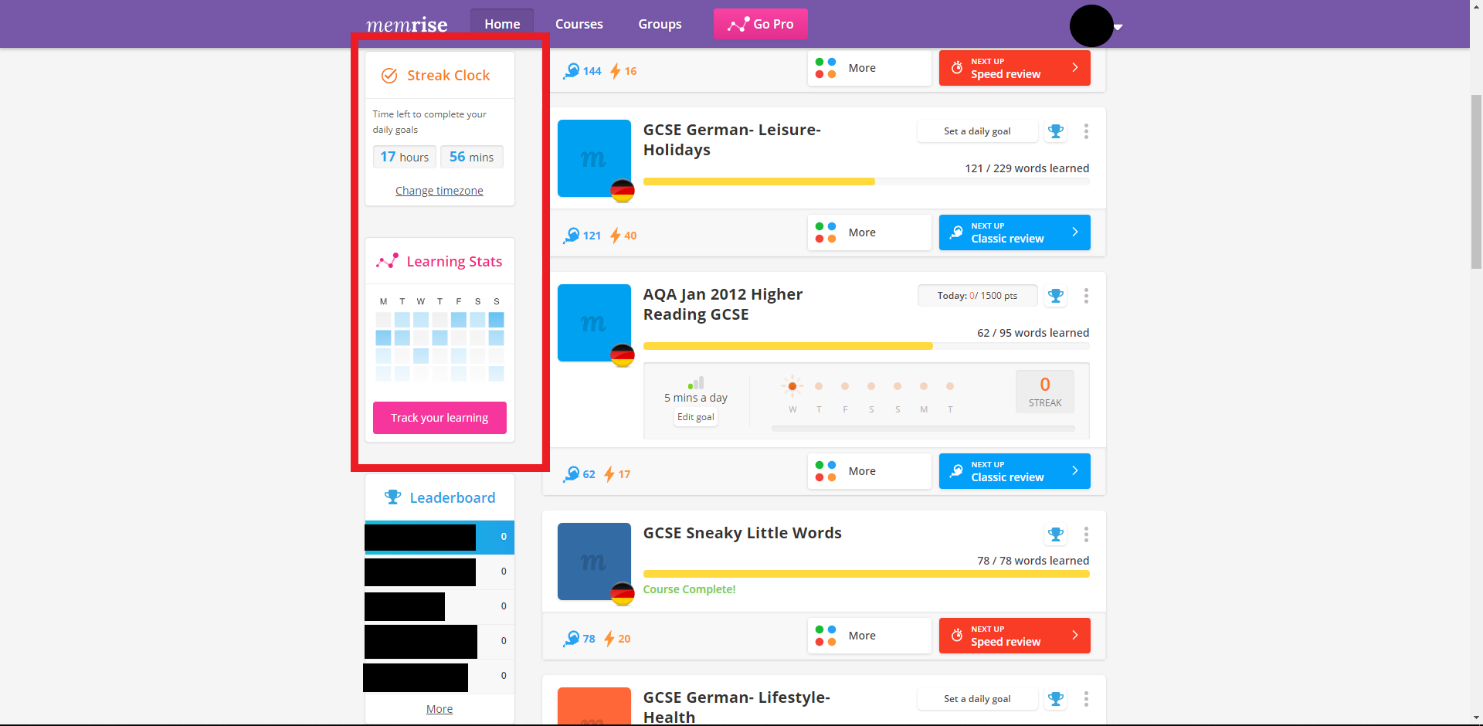

Figure 2 shows the ‘Streak Clock’ and ‘Learning Stats’, both of which aim to prompt the user to access the site consistently and regularly. The use of a daily streak encourages the user to come back and learn regularly. I hope to include a form of incentive in my solution.

Figure 3 Figure 4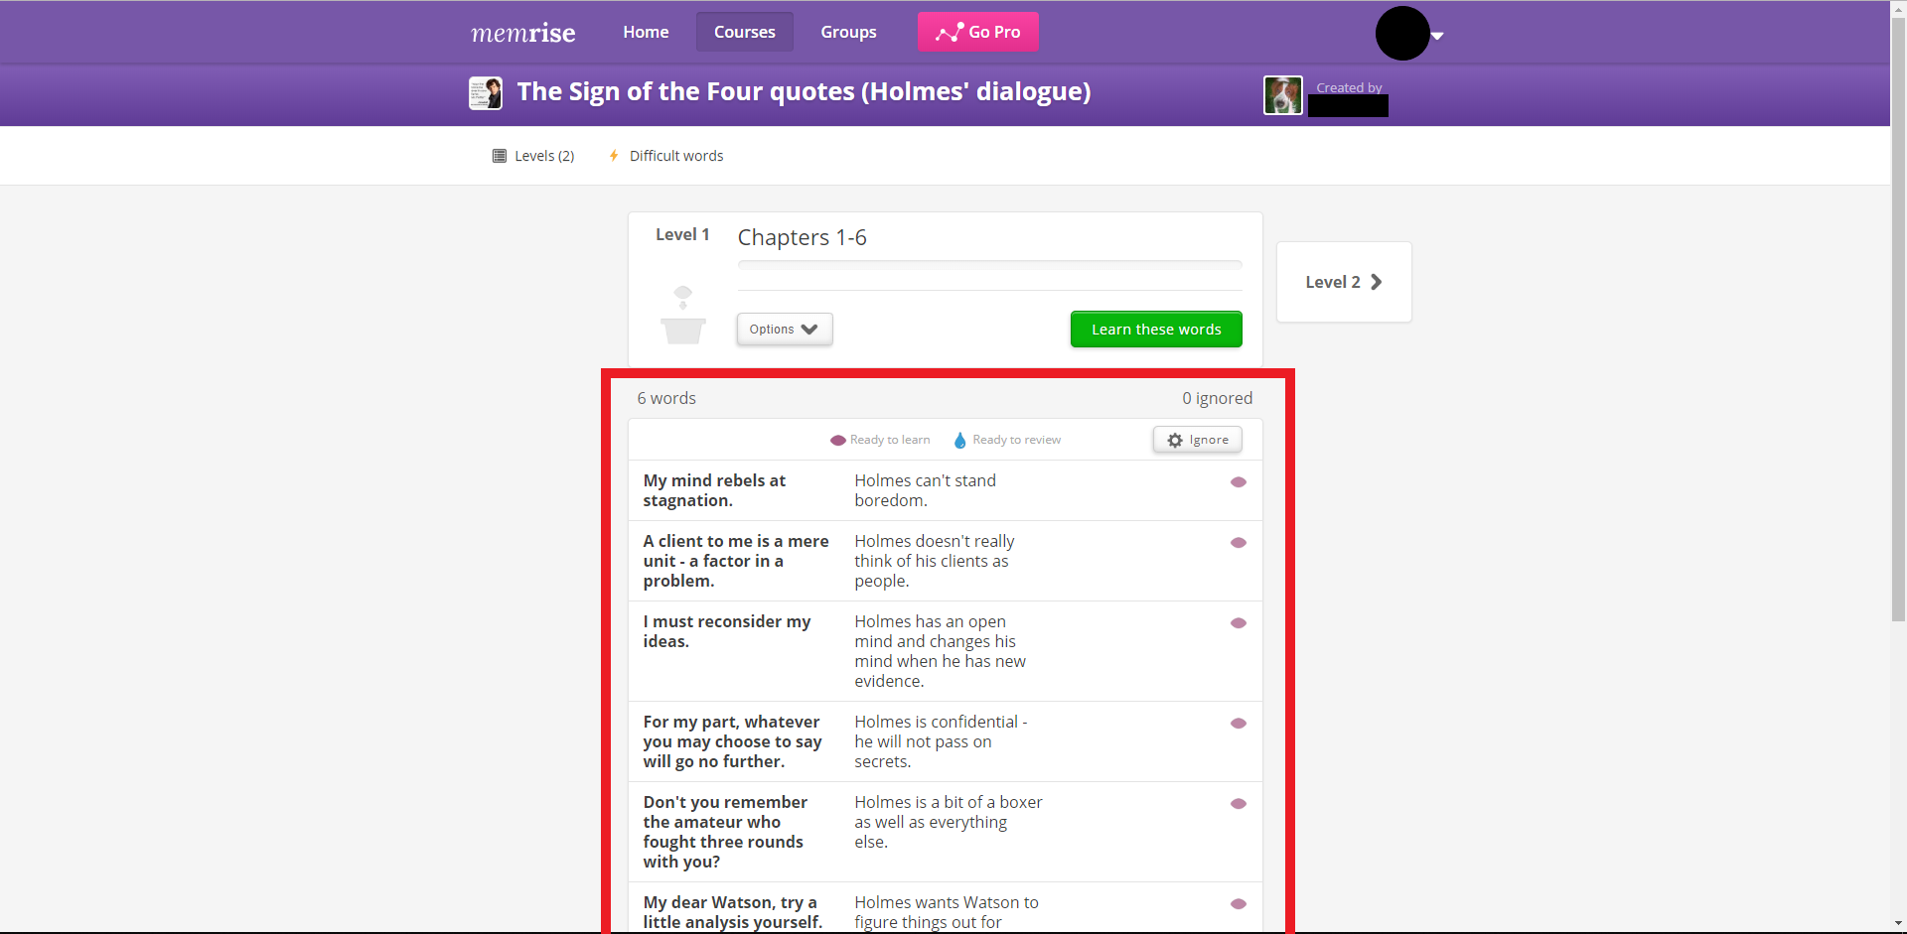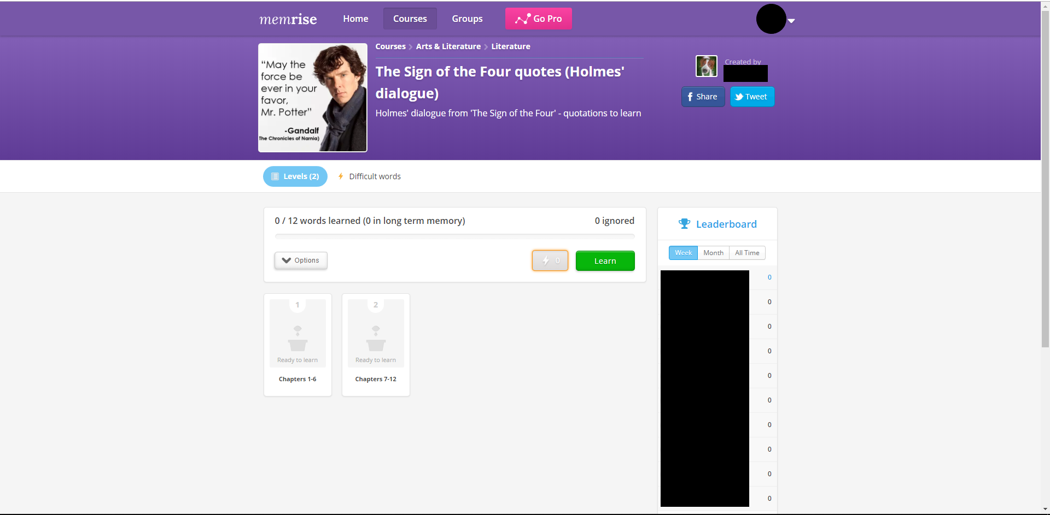

Figure 3 and Figure 4 show the interface for the individual courses on Memrise. Courses are often broken down again into levels, and this compartmentalisation helps to prevent the user from being overwhelmed by too many tasks. Specific levels can be previewed and played. The navigation is clear and easy to use, with the use of symbols for completed/incomplete words or phrases.

Figure 5

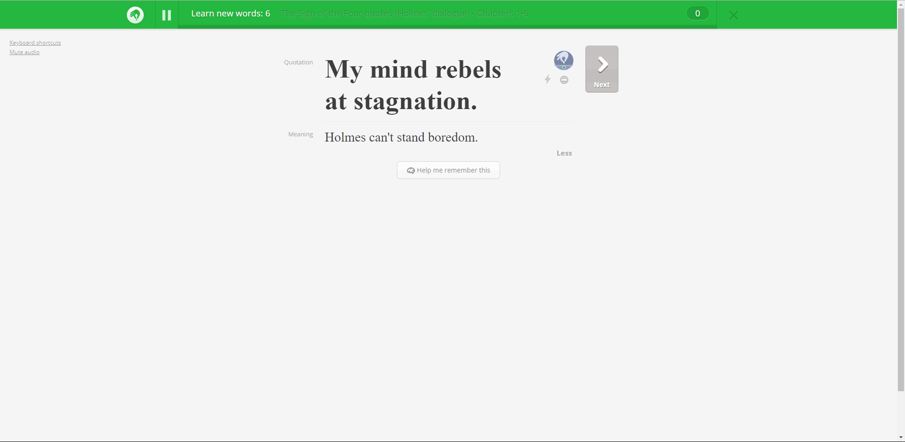

Figure 5 shows the interface for a singular word or phrase. It is first introduced to the user with the phrase itself and its meaning, with no pre-defined time frame, to allow the user to continue at their own pace. Meanings or definitions may not be required for orthographic assistance. Symbols such as the pause button and the next button are clear for navigation and add to the simple interface.

Figure 6

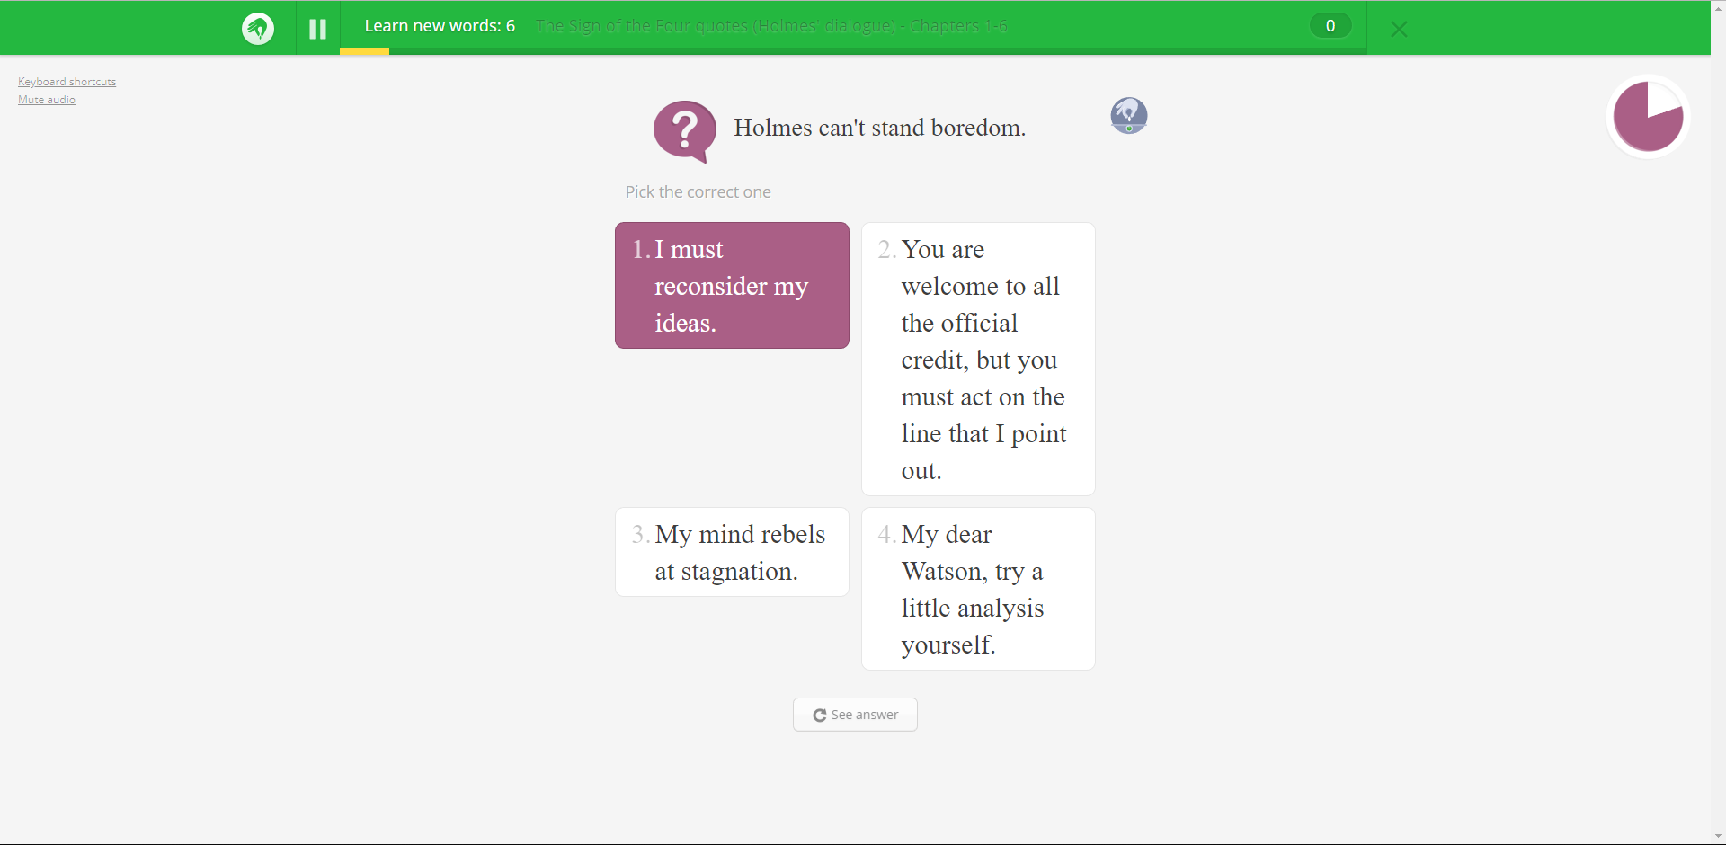

Figure 6 is an example of one of the ways in which Memrise tests its users. The user must connect the correct meaning to the phrase, from 4 options. The multiple-choice aspect to this solution works very well when the user is tested extensively and frequently. This solution also tests users with audio clips of the phrase/meaning, allowing the user to type in an answer. I intend to user this form of memory retention in my solution.

Figure 7

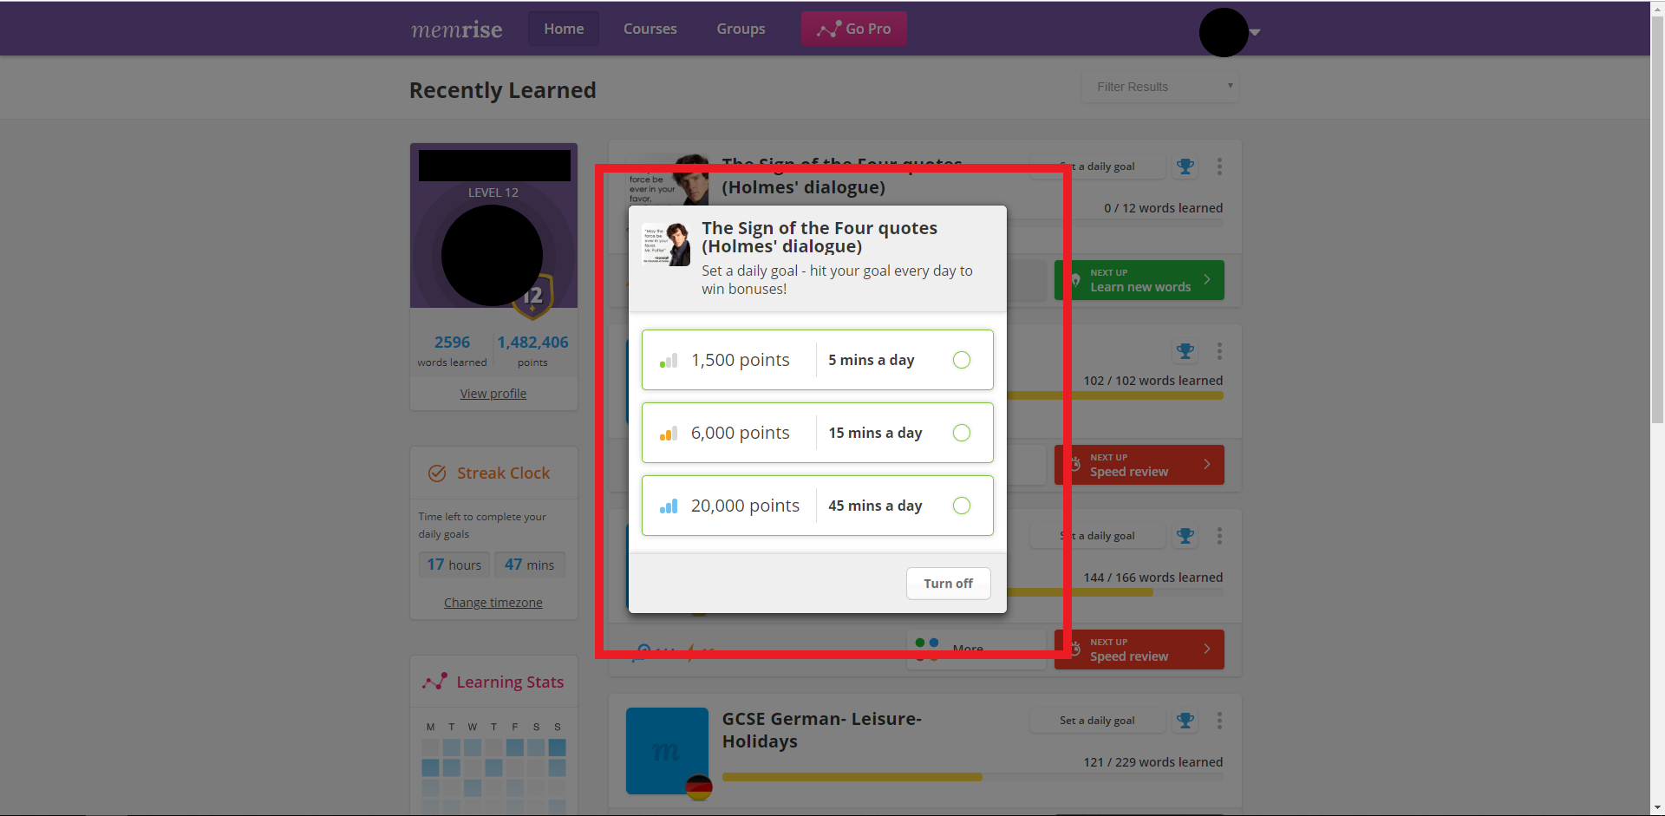

Figure 7 demonstrates the incentives used by the solution to encourage the user to use the solution more frequently. The user is given the choice on how much time is spent on a particular course a day. This goal has to be met every single day for the user to maintain a streak.

Figure 8

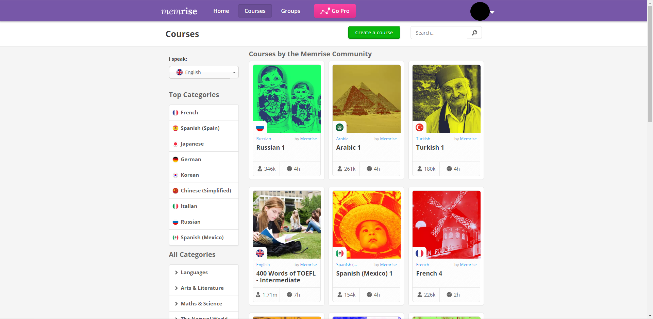

Figure 8 shows the community aspect to this solution, presenting community-made courses for other users to play and share between each other. Courses may be filtered by categories, of which there are many. This solution also provides users the ability to create their own courses and share them within the community.

Figure 9

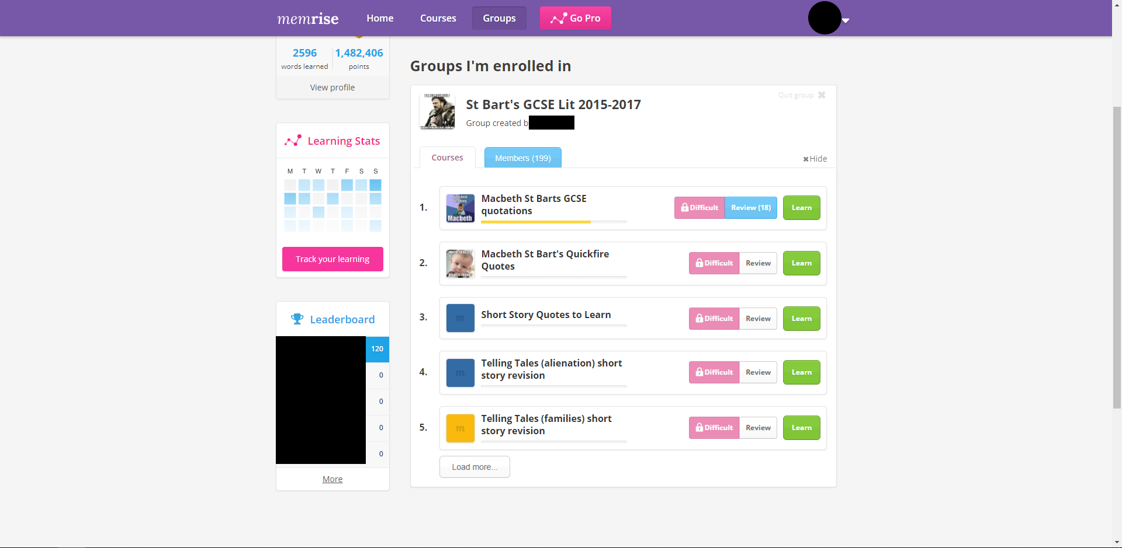

Figure 9 shows the use of groups to connect users together, for example in classes, so that resources may be shared between several members. Groups can be assigned courses and a group leader board can allow users to compare their progress with fellow members. This competitive aspect is also a fun incentive for the user to continue using the service.

Figure 10

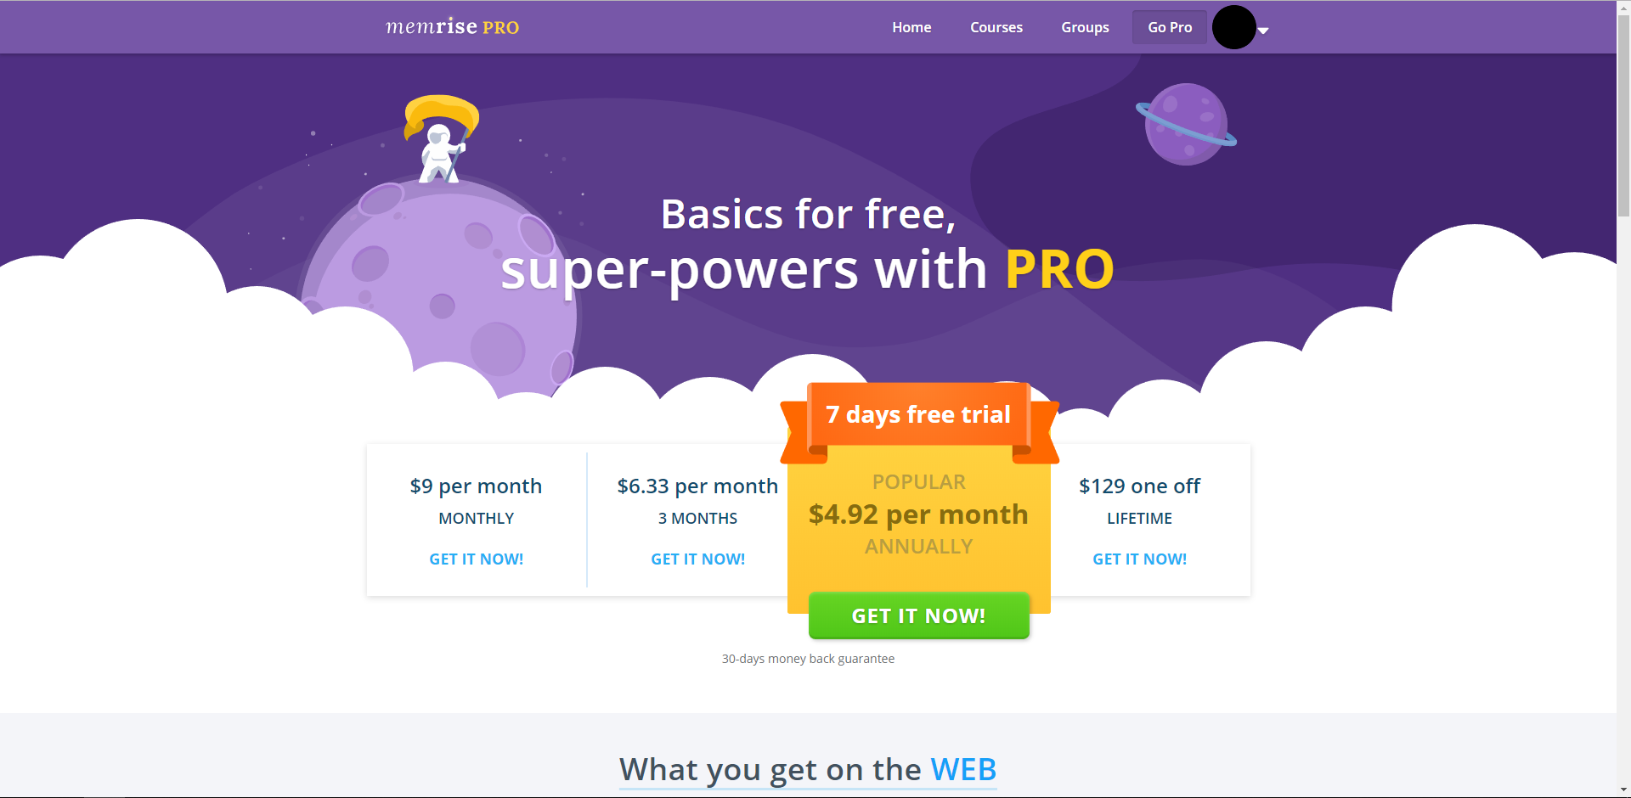

Figure 11

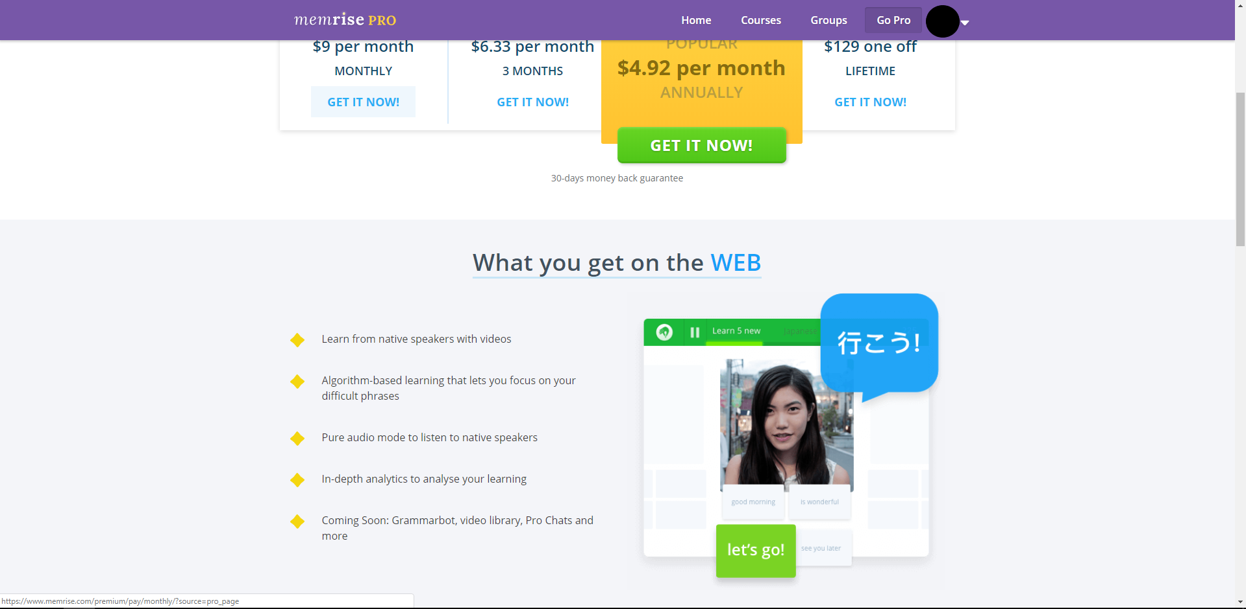

Figure 10 and 11 show the premium option for this solution, in the form of a monthly subscription. For the price of around $5 a month (as of Oct 2018), the user gains the ability to watch videos and audio clips from native speakers, as well as in-depth analytics. These features are not a necessity, so the solution does not force the user to provide money, but the features are useful and available to the user if they chose to be financially invested.

This particular solution does not directly line up with my problem of providing orthographic assistance, since the solution focuses around translating phrases from foreign languages to the user. However, Memrise is still representative of a program that aids memory retention, and it does this incredibly well. My experience using Memrise was mostly positive. The user interface is aesthetically pleasing with the use of a consistent colour scheme and a simple design. The menu navigation is also easy to follow, and the breaking down of phrases into courses and levels is helpful at not making the user feel overwhelmed. The social aspect to this solution is integrated very well, with the connectivity of users being strictly tied to the sharing of knowledge. Finally, Memrise is very effective at using incentives, such as the daily streak and leader board, to get users to come back regularly to the program, which will ultimately help improve their learning and knowledge.

The shortfall in this solution is the lack of output utilization. Memrise does use audio output to test users on certain phrases, but only as a compliment to the text displayed on the screen. Testing users solely on their ability to interpret the spoken word would add an interesting dynamic to the solution, making it more fun and enjoyable, especially to a younger audience.

# System 2: Nessy

Development studio: Net Educational Systems, Ltd

Initial release: 2007

Release price: £8/Month (per student)

Platforms: Web

Type: Web-based mini-game collection, designed to improve reading and writing

Alexa rank (website traffic): 275,117 (Oct 2018)

Net Educational Systems (Nessy) has been making educational software for children since 1999 and has developed a reputation for exceptional quality among schools and teachers. Nessy offers a solution tailored to children with learning difficulties, with a collection of multisensory products aimed at making learning to read, write and spell fun. These products have been used globally by thousands of teachers and students and is a 3-time winner at the prestigious Educational Resources Awards.

Nessy Reading & Spelling is a web-based program developed by a team of specialist teachers and psychologists. With 100 independent learning lessons, this solution employs an intensive, multisensory, and sequential method of instruction, which adheres to the Orton-Gillingham approach to reading & spelling. Lessons put emphasis on phonemic awareness, phonics, blending, sight words, fluency, spelling, vocabulary and comprehension. Such lessons are composed of strategy videos reinforced with games which teach fundamental reading & spelling skills.

Figure 1 Figure 2

Figure 1 shows the character customization within this solution. Each user is allocated a ‘monkey’, which they can personalize to reflect their own persona within the game. For the young audience that this solution is catered to, this customization is enough to give the impression that this game offers a unique experience, despite it only having 4 levels of customizability. A supervisor can also edit the level of access each user has for this solution. Figure 2 shows the selection panel for the various learning options for this solution. My research will only cover the spelling aspect to this solution. Both Figure 1 and 2 display bright colours (green, blue, yellow) that follow a consistent art design of wooden planks and panels. This continuity is aesthetically pleasing to the target audience.

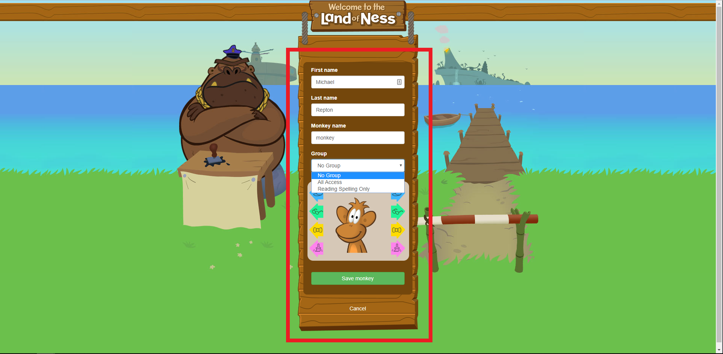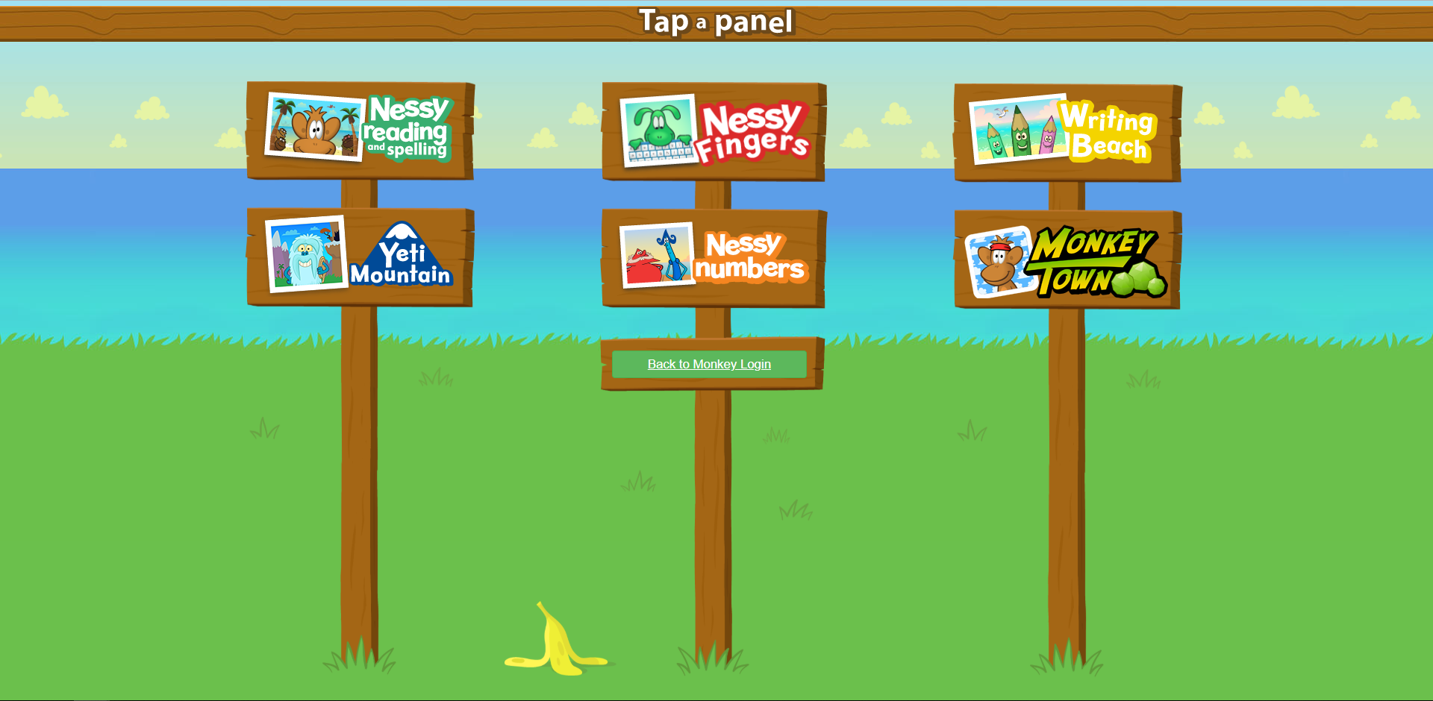

Figure 3

Figure 3 shows the initial screen displayed to the user when they login. It provides a basic backstory to the premise of the game. This part of the solution does not provide orthographic assistance, but its inclusion contextualizes the game to make it more interesting and engaging for the target audience.

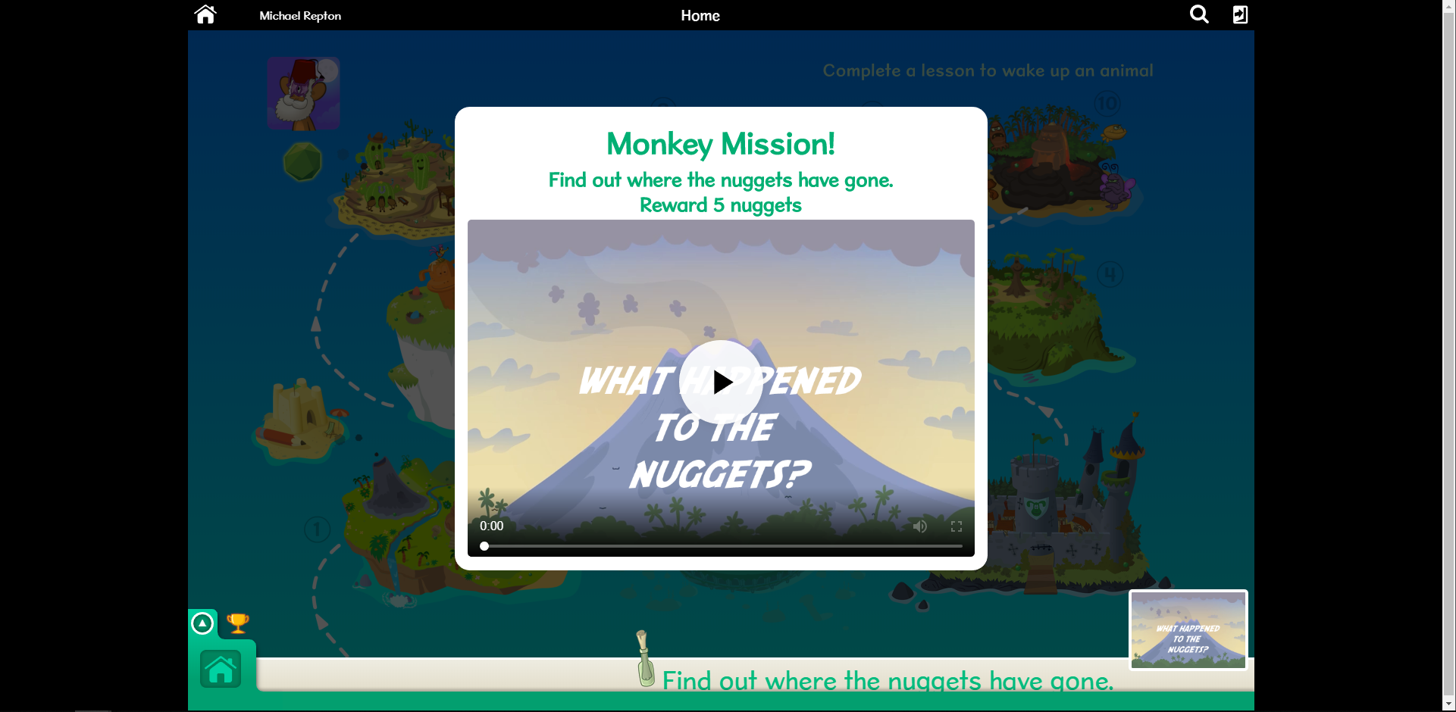

Figure 4

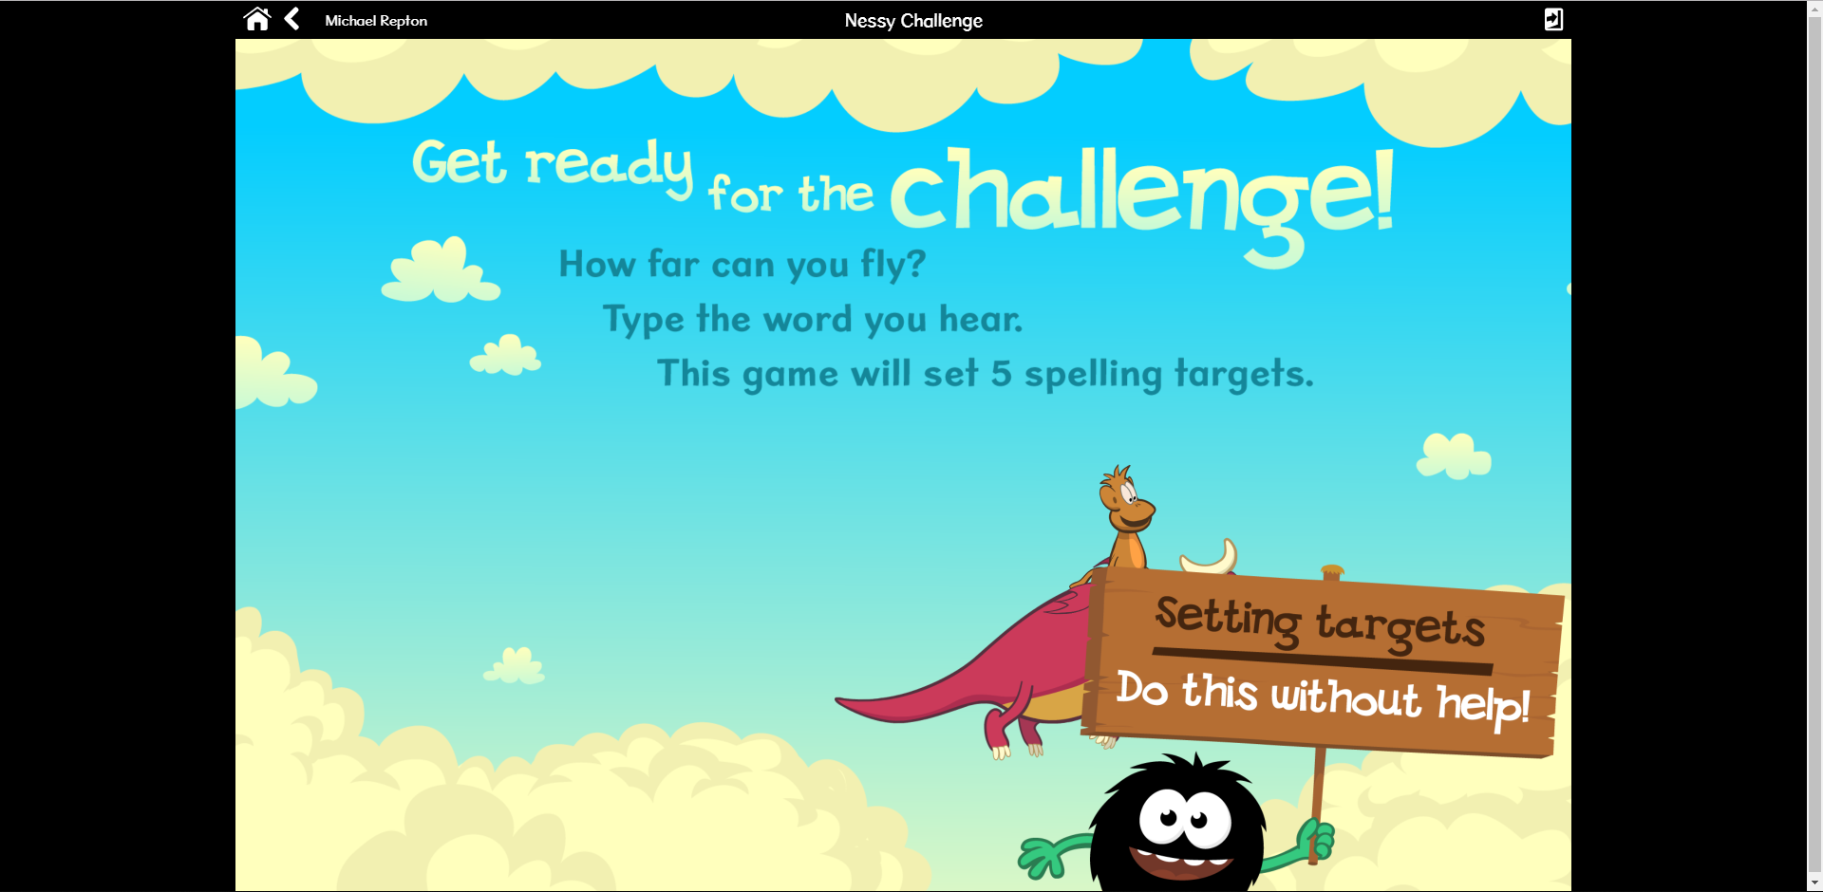

Figure 4 shows the instruction screen displayed to the user when they begin a game. Once again, bright colours and the consistent ‘wooden’ design is used. The instructions shown are clear and easy to understand, held within the context of the game to make the solution more engaging.

Figure 5

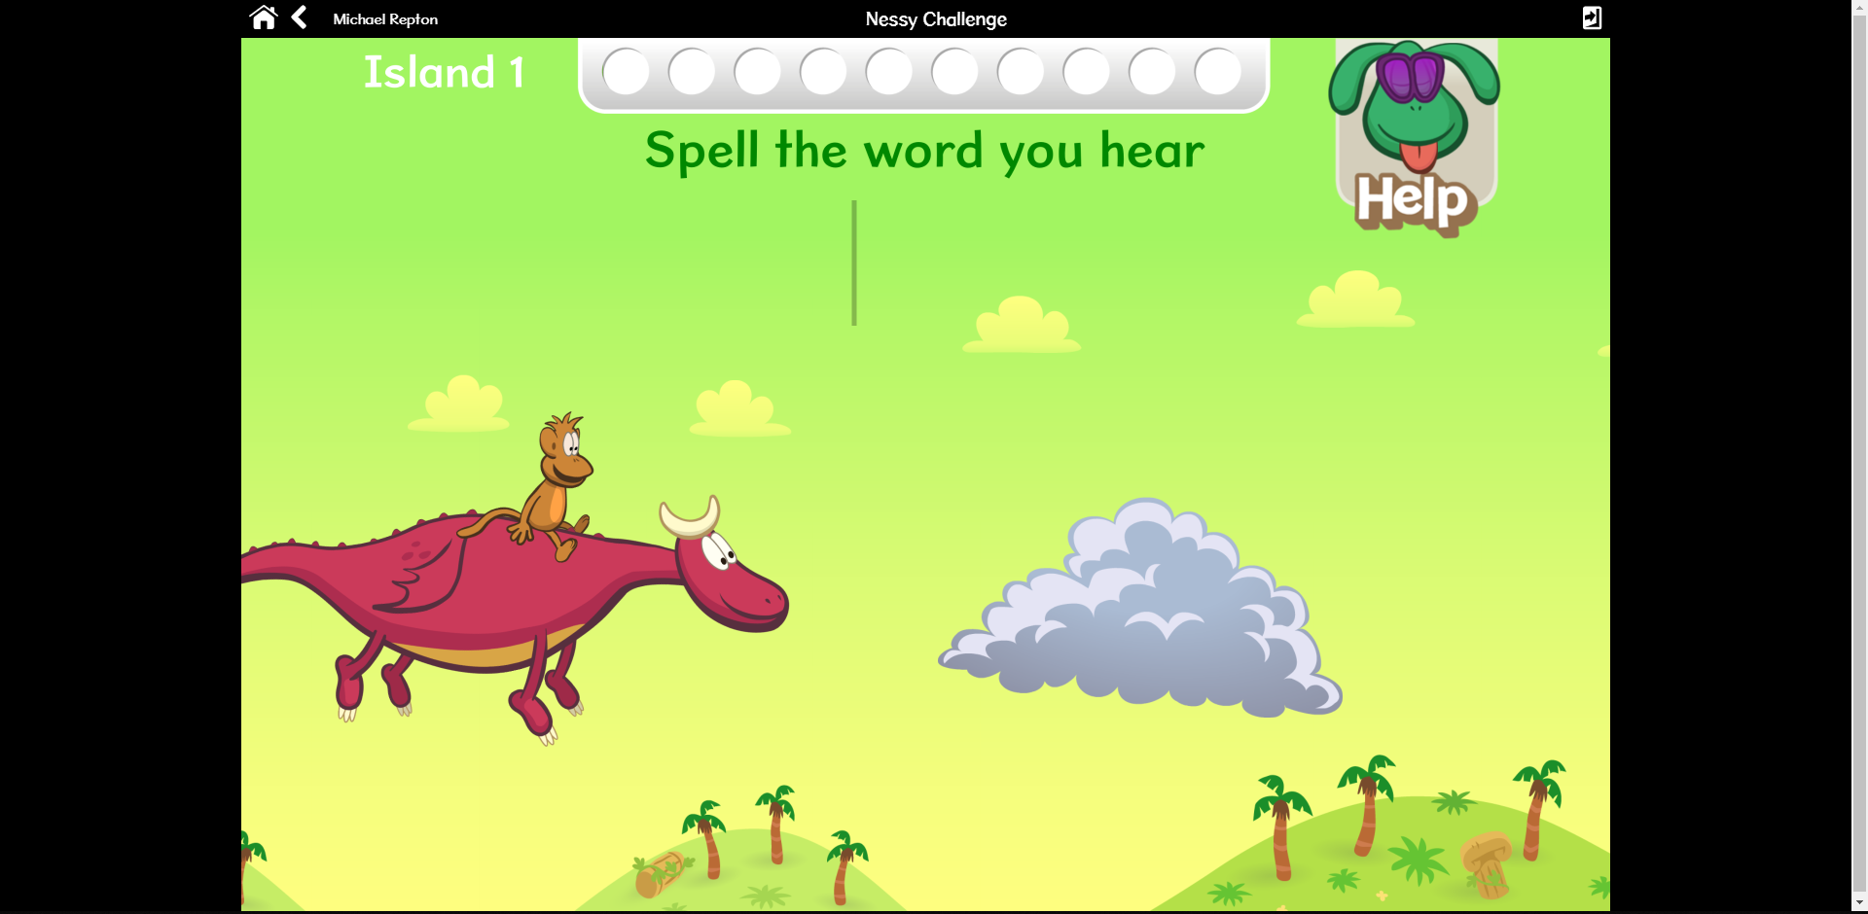

Figure 5 shows the input screen for a word within an ‘island’ or level. As soon as this screen is shown, an audio clip of a word is outputted to the user through their default audio device. The simple concept is to type in the word that is spoken aloud. The monkey and dragon have a subtle animation which would be interesting to look at for a user aged between 4 and 8. Bright, contrasting colours used. This screen is simple and easy to understand.

Figure 6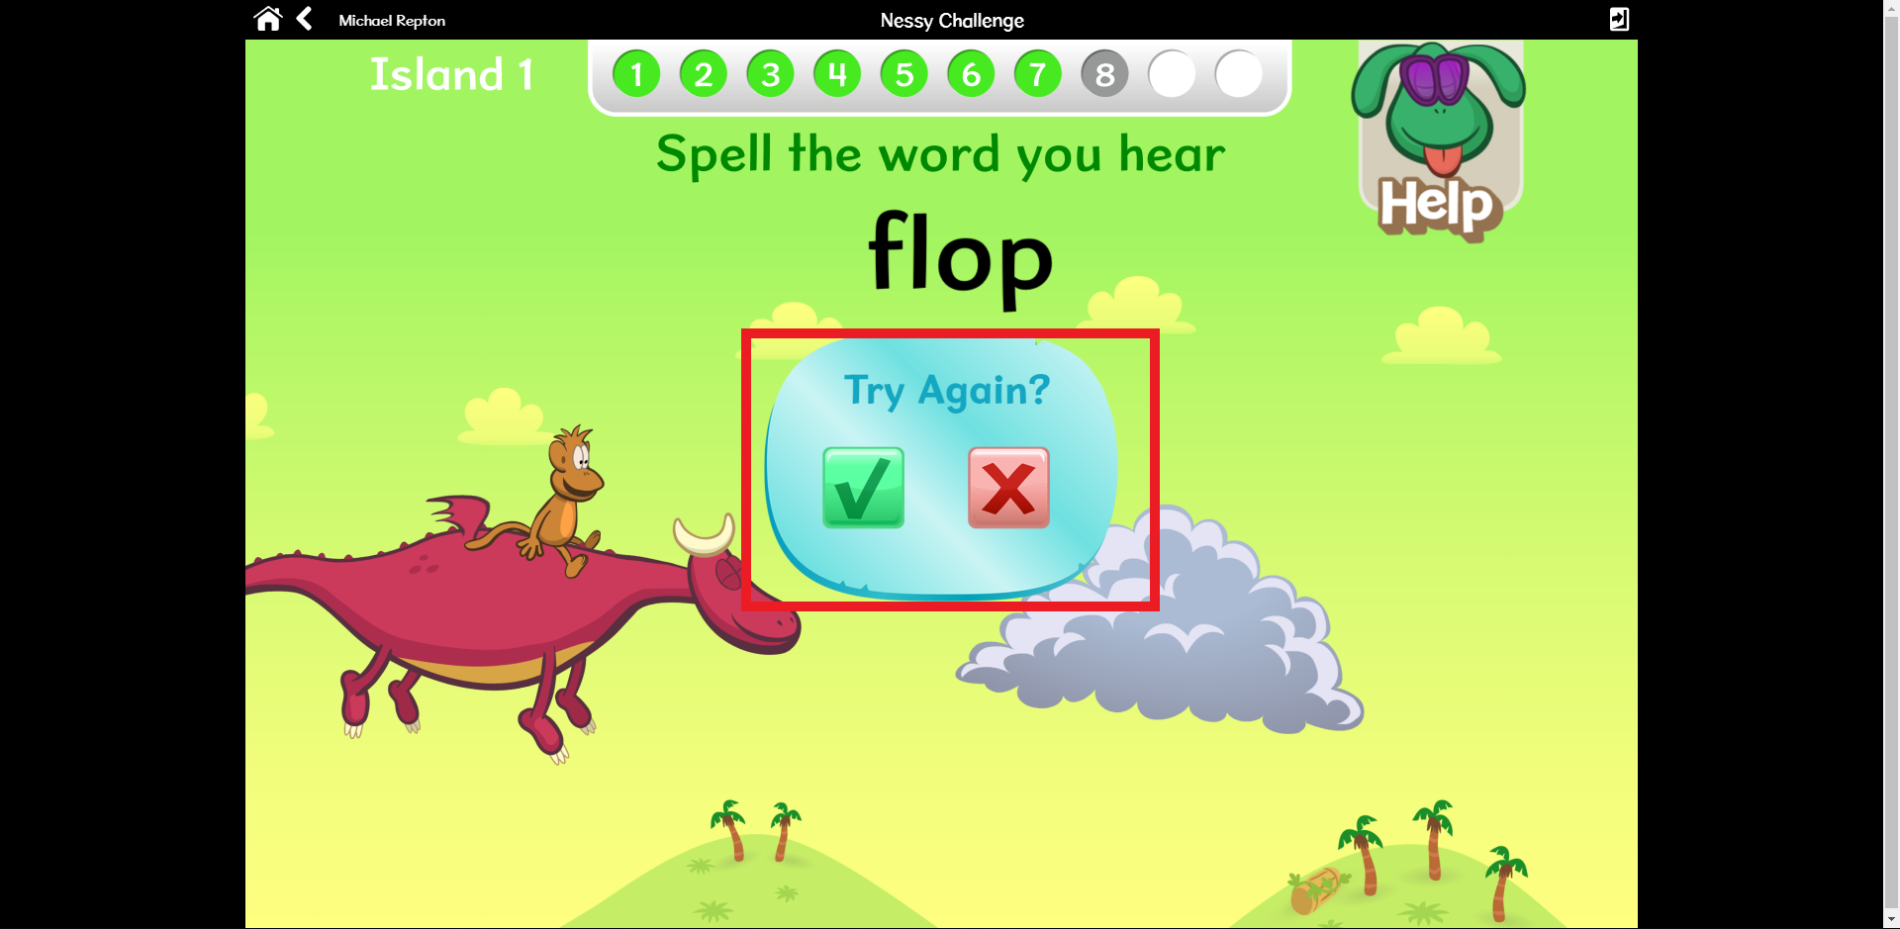

Figure 6 shows the ‘try again’ dialog window that pops up when the word inputted is not the same as the word spoken (incorrect). This window indirectly informs the user that they were incorrect. They can then decide to try again using the buttons. This element of the game makes it fairer for those who struggle more than others. The ‘help’ button plays the audio clip again.

Figure 7 Figure 8

Figure 7 and Figure 8 show more input screens for different ‘island’ s or levels of varying difficulty. The numbers displayed along the top of the screen represent the user’s progress through the ‘island’, with each number and colour showing a word and whether it was inputted correctly. Note that grey represents an incorrect answer/input. This colour is seen as less harsh on the eye than red for the young audience, prompting them to see their mistakes as learning experiences.

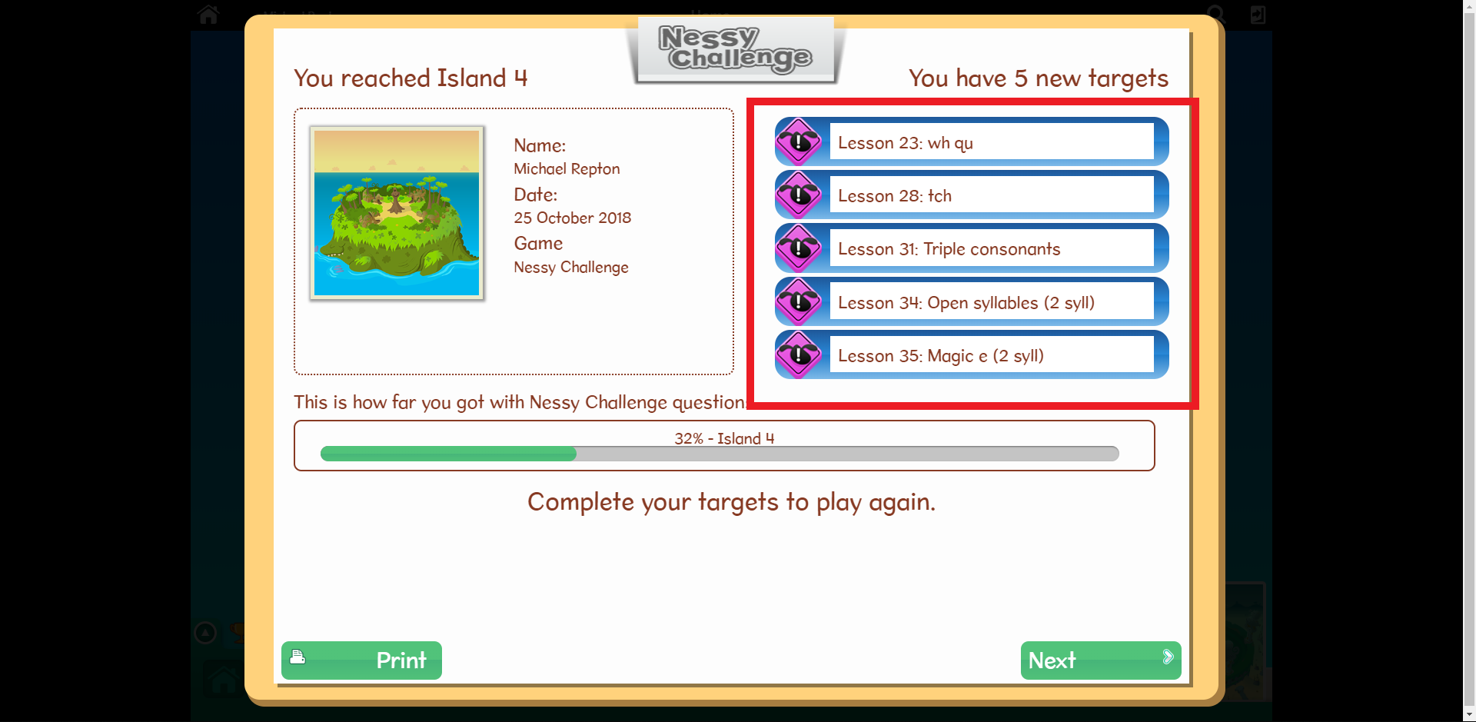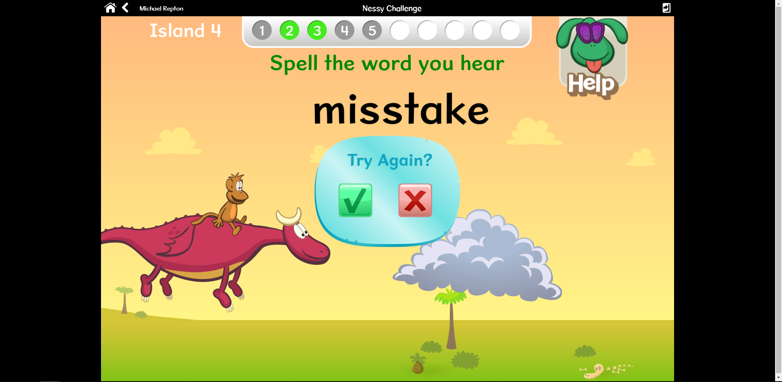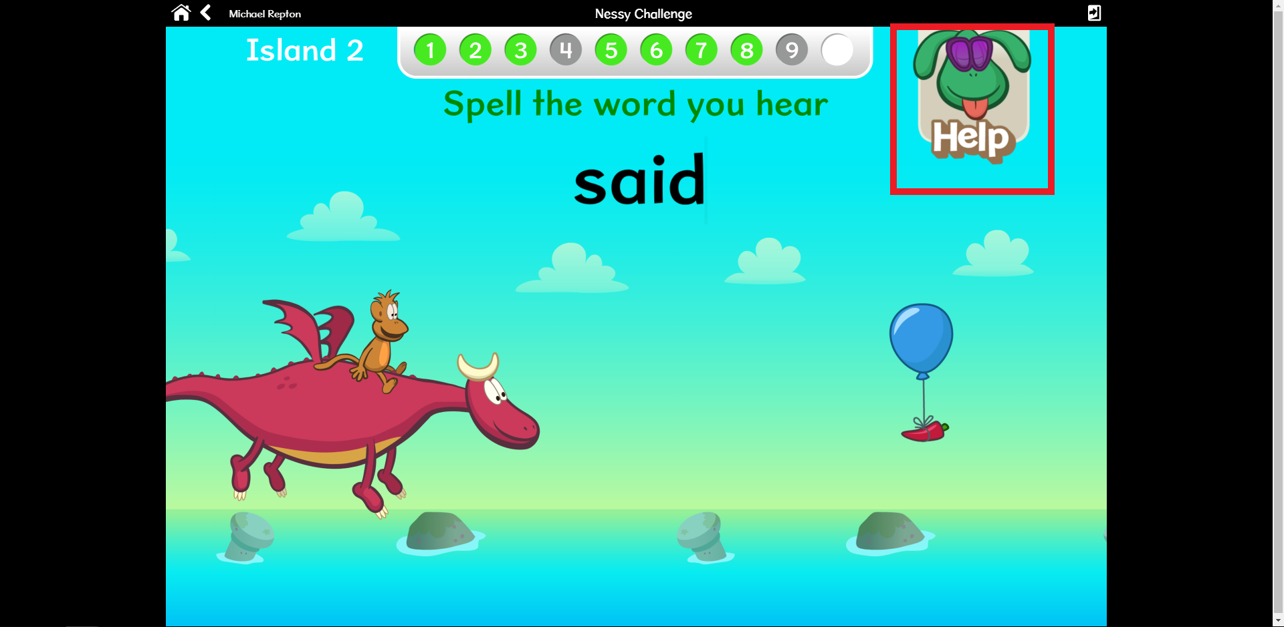Figure 9

Figure 9 shows the summary of the ‘island’ or level just completed by the user, presenting their results and progress. A supervisor may use the ‘targets’ panel to test specific areas of difficulty for the user. Targets correspond to lessons which may be accessed individually.

Figure 10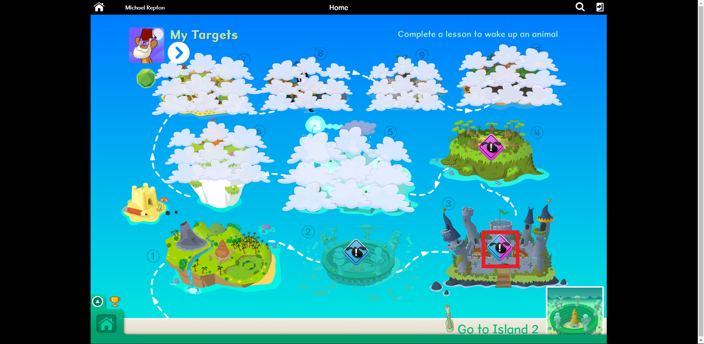

Figure 10 shows the main menu, representing a zoomed-out look at all the individual ‘islands’ available to the user. Targets applying to particular ‘islands’ are shown as hovering notifications, colour co-ordinated to either spelling or reading.

Figure 11

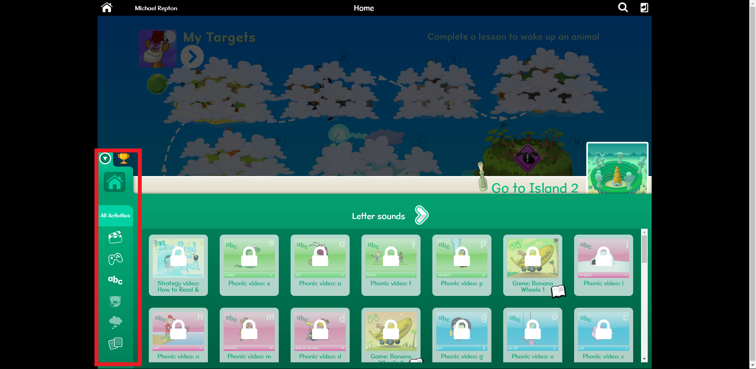

Figure 11 shows the main menu pull-up tab, which contains all the lessons and videos provided by the solution. The use of this pull-up tab creates a simpler interface for the user, without all the clutter that the user has no interest in.

Figure 12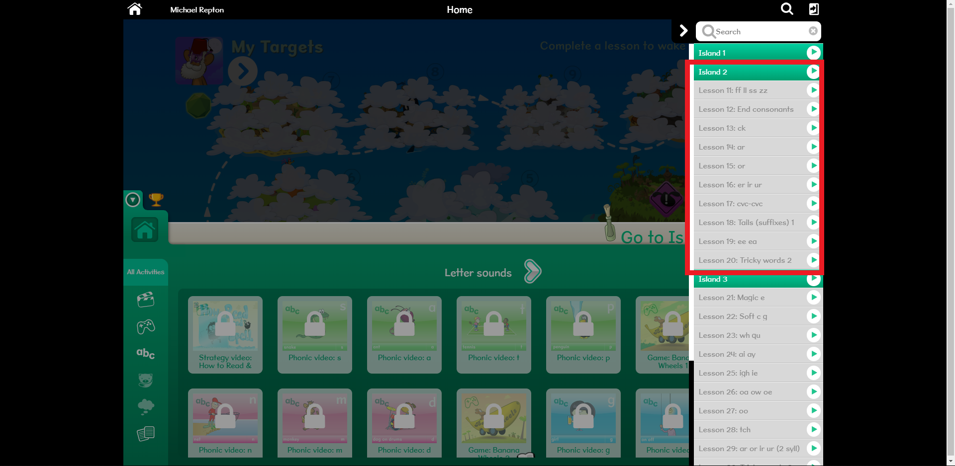

Figure 12 shows the main menu search tab, which allows a supervisor to access a specific lesson. The tab is revealed from a simple ‘search’ icon in the top right of the screen.

Figure 13

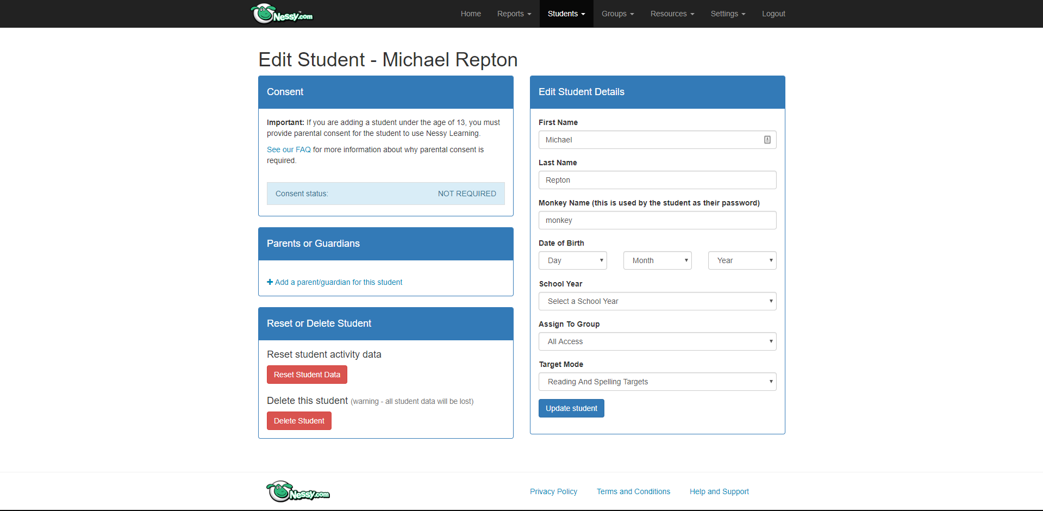

Figure 13 shows the supervisor viewing panel. This panel is held behind a password that is only available to the supervisor, preventing unwanted access. From here, the supervisor can access and edit student information which is held by a Nessy-hosted student database.

Figure 14

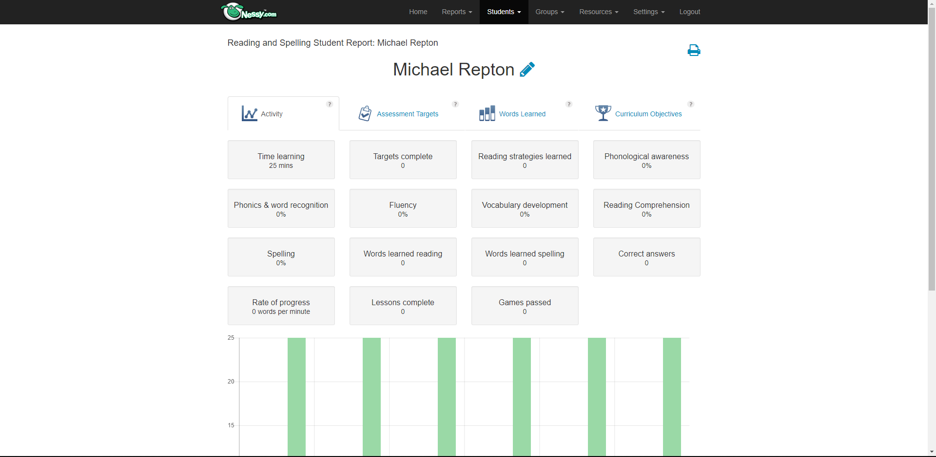

Figure 14 shows a report created on a specific student from the Nessy-hosted student database. Useful information can be gathered from here, allowing the supervisor to tailor their teaching to the user.

Figure 15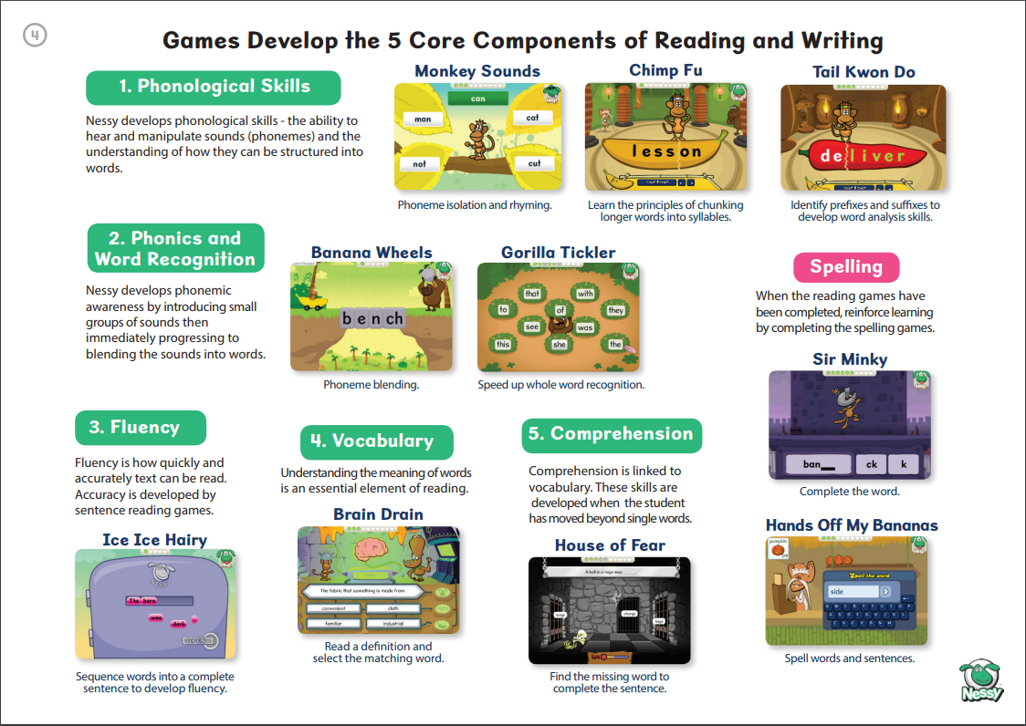

This program is most closely related to my proposed solution. The research on this solution has been the most helpful, due to the program’s focus on improving spelling accuracy and its experience of being used within many schools worldwide. As a whole, the solution is incredibly stable and aesthetically consistent. Nearly every detail of this program has been centred on the interests of a young audience, such as the use of an engaging contextual story behind the game itself. Working through the game is an incredibly engaging experience, and this is mainly down to the simple interface presented to the user. Pull-up and button tabs make navigating the solution incredibly easy, and being able to understand the game you are playing is the most important factor of such a solution. Behind the scenes, the program works efficiently in providing a unique, tailored learning experience.

The shortfalls of this program lie in its cost and size. For a group of 10 students, each student would be charged £20 each to access this service, billed over a year period. This could be achievable for a school to fit within their budget, but this program is essentially non-accessible for smaller, independent supervisors such as the stakeholder in this project. Furthermore, the size of this solution, with all of its features and lessons, is difficult to comprehend, and this factor could be overwhelming to the main supervisor considering the cost. The solution also lacks a social aspect to the game which would introduce engaging competition.

# System 3: Grammarly

Development studio: Grammarly, Inc

Initial release: July 2009

Release price: Freemium (£8.90/month)

Platforms: Windows, MS Office, Chrome Extension

Type: Online text editor with grammar checker, spell checker, and plagiarism detection

Alexa rank (website traffic): 561 (Oct 2018)

Grammarly, developed in 2009 by Alex Shevchenko and Max Lytvyn, is an online grammar checking, spell checking, and plagiarism detection platform developed by Grammarly, Inc. The solution’s proofreading and plagiarism-detection resources check against more than 250 grammar rules, with the backend grammar engine written in Common Lisp.

Grammarly’s AI-powered algorithms flag potential issues in a string of text and suggest context-specific corrections for grammar, spelling, wordiness, style, punctuation, and plagiarism. Millions of writers worldwide use Grammarly’s products, making this solution the most popular out of the three researched, which are also licensed by more than 600 leading universities and corporations. Grammarly particularly helps students improve their writing in essays and reports, although professionals also use Grammarly to gain expert help and instant feedback on the accuracy, and credibility of their English writing in a variety of fields, such as marketing, and journalism.

Figure 1

Figure 1 shows the main menu interface for this solution, with tabs on ‘Profile’, ‘Premium features’, ’Support’ and a log out button along the left. The larger, right panel displays all the documents that have been scanned using this program, including a search bar to filter through them. The titles of the documents are displayed in the thumbnails along with the amount of errors currently present in the document. The first thumbnail can be clicked on to import the user’s personal documents.

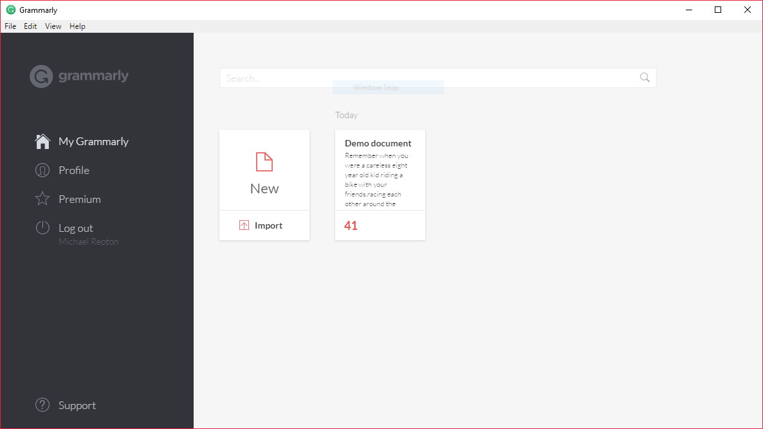

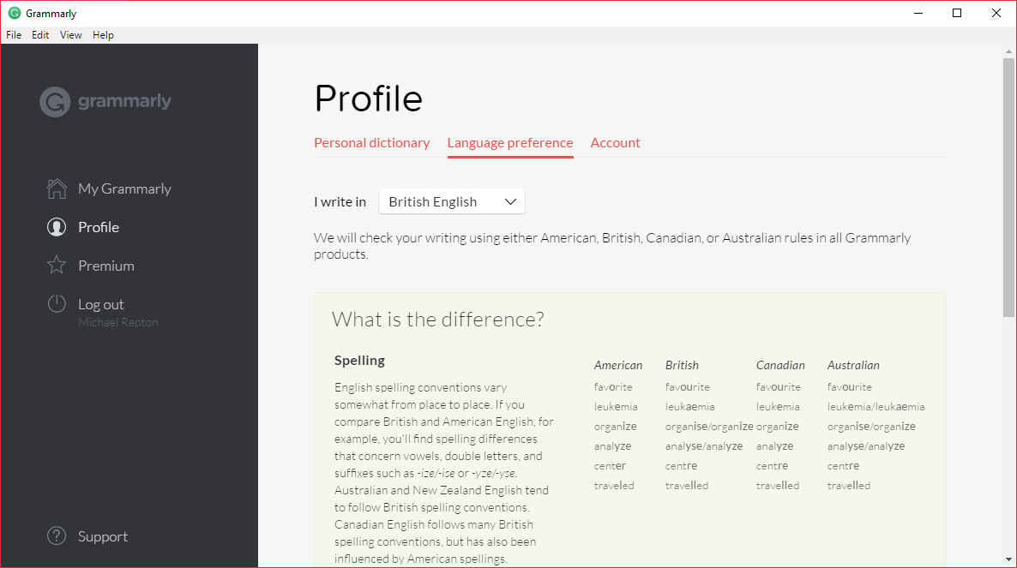Figure 2

Figure 2 shows the ‘Profile’ panel, with options to add words to a personal dictionary of exceptions for the program, change language preference and edit personal account details. This interface is very simple with the inclusion of very basic, contrasting colours. This design choice pulls all focus on the documents themselves rather than the features being applied to the documents.

Figure 3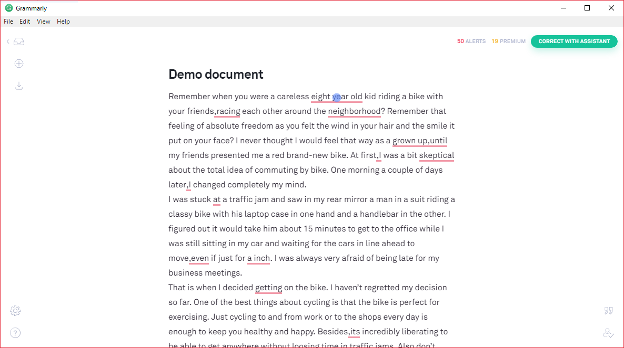

Figure 3 shows the outlook view of a selected document. The raw text content of the document is displayed, along with red underlines to represent mistakes in spelling and grammar. From this outlook, the user may select specific errors and edit them. The use of red underlines in this design makes the errors apparent to the user and prompt them to clear the entire document of errors.

Figure 4 Figure 5 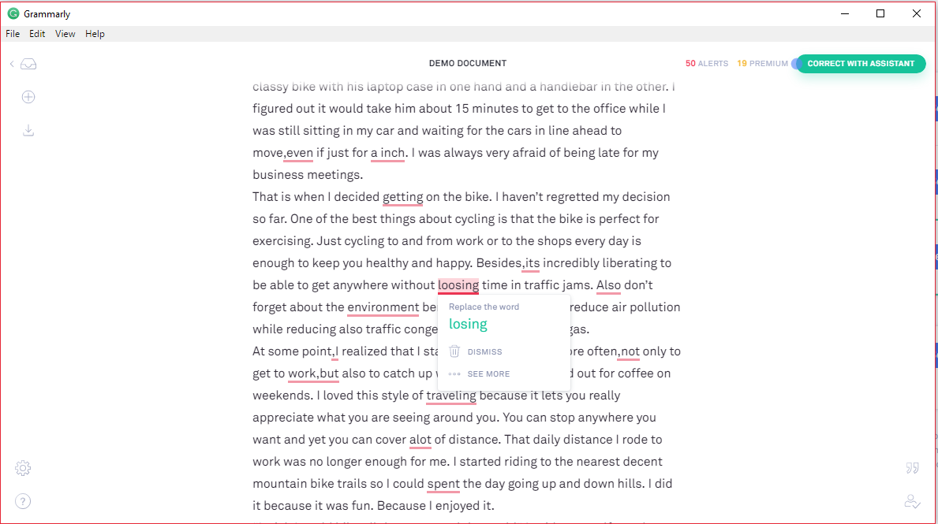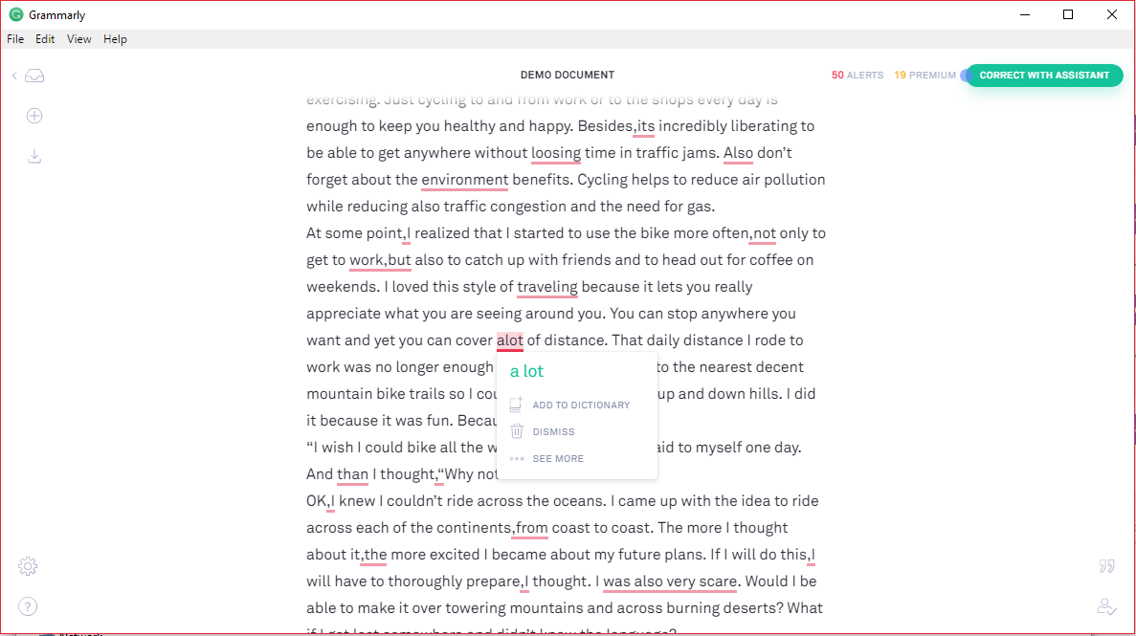

Figure 4 and Figure 5 both show the interface for viewing errors detected within the document. A command is given to the user to prompt a response, such as ‘Replace the word’, along with the correct version and the option to dismiss the error. This mini window clearly displays all the information the user needs to know, and is shown when the user clicks on a specific error.

Figure 6

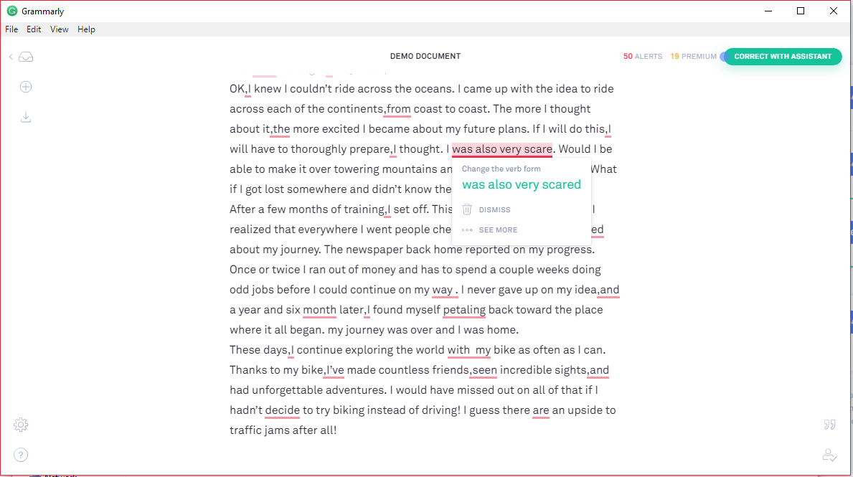

Figure 6 shows another example of an error within the document. The solution is able to detect errors from context, which is a complex algorithm that most word processors do not include.

Figure 7

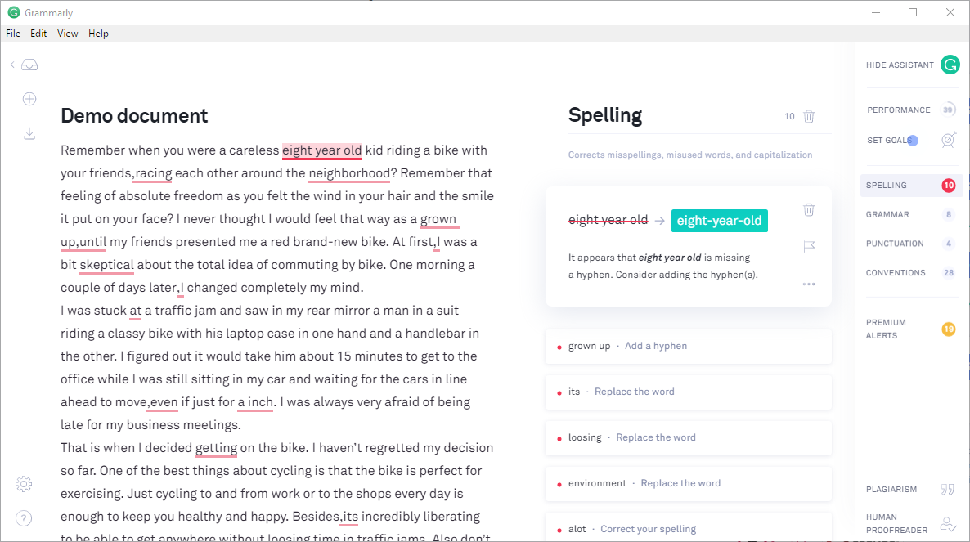

Figure 7 shows the interface for the Grammarly ‘Assistant’, which guides you through each error chronologically in the document. This assistant clearly displays each error with a simple breakdown of where the mistake was made. Errors are also compartmentalised into spelling errors, grammar errors etc…

Figure 8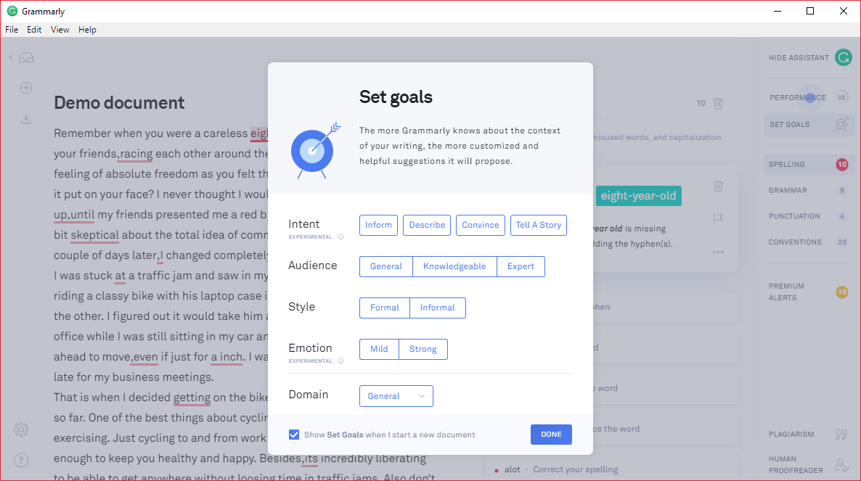

Figure 8 shows the ‘Set goals’ input panel within the Grammarly ‘Assistant’. The inputs provided by the user allow the program to correctly handle errors based on the intent, audience and emotion of the document. The spell-checking algorithms for this solution work far better when provided with context.

Figure 9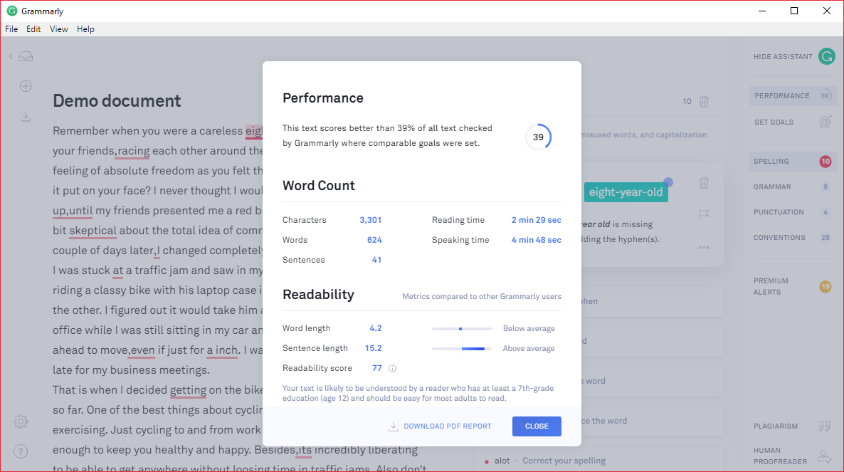

Figure 9 shows the ‘Performance’ panel within the Grammarly ‘Assistant’, which outputs information and scores upon the word count and readability. An overall score, which in this case is 39, is then calculated and used to rank the document against other documents graded by other Grammarly users.

Grammarly performs exceedingly well in its purpose of outputting spelling and grammar mistakes. The AI-powered algorithms within this solution manage to detect errors made in spelling with reliable accuracy. The simplicity of this solution also makes the program easy to follow and use, with the error detection being the focused feature. The simple, contrasting colours within the design match the targeted audience of mature students and adults accordingly. Users of this program can easily identify errors within their own documents and update them to be more accurate.

Whilst spelling error detection is a part of orthographic assistance, this particular solution fails to teach spelling solutions to its users, as it only presents the solutions. If the accuracy of this program was tied to a learning aspect targeted towards young users, this solution would provide an efficient and accurate learning experience.

# Research Summary

To summarise, my research shows me that this problem could feasibly be computerised. There are many similar products on the market, and from exploring a few of those, it is clear that a non-computerised system would not be viable. Upon the specific problem of orthographic assistance, all current solutions are computerised and contain large data storage and processing which would not be possible without a computer. The current systems also demonstrate that a simple but powerful UI is crucial at appealing to the target market, and that users expect a robust interface to be truly invested in the program.

Due to the nature of my solution, certain features and design choices are essential.

The program must provide orthographic assistance, which has certain requirements:

* The user’s experience must be tailored and unique to them, depending on their current level of knowledge and understanding.
* There must be a sense of progression and completion, so that the user feels that there is an end goal to work towards.
* Audio devices will be utilized as a means of testing the user’s ability to spell.
* Incentives must be implemented into the solution to encourage an effective and consistent learning experience.
* The solution must cater to any level of skill/difficulty. A user with a lot of previous knowledge could still benefit from this program.

The program will require a user interface with these features:

* The ability to navigate through the whole program in a logical way, using submenus. This navigation will be clear and easy to understand, considering the intended audience of children aged between 4 and 8
* It must be intuitive to use with either a mouse or keyboard, with clear navigation buttons. It should have a graphical indication of where the user is within the program.
* A consistent, colourful design which appeals to the intended audience. Its simplicity will be easy to interpret and navigate, using symbols instead of words, for example.
* An options menu, with choices for graphical, audio, and gameplay difficulty settings.

The program will have the following requirements for storage:

* An encrypted database for user profiles, containing no personal information. This database will take up no more than 50Mb in storage space and will be stored local to the program files so that it may be accessed quickly.
* The final executable file should take up less than 200Mb storage space, as the largest existing system I researched only required 47.6Mb. This does not account for any files created and saved by the program.

For the hardware the solution should be able to run on:

* A typical, budget PC:
  + 1 GB of RAM minimum.
  + 2 GHz dual core processor (or equivalent) minimum.
  + 200 MB of free storage.
  + An internet connection.

I intend to design, develop and compile the program to run on x86/64bit windows machines, since these are the most common PCs as of October 2018. Furthermore, the stakeholder in this solution has access to such a device, making this decision appropriate. If successful, the solution may later be ported to other systems, such as MacOS.

I will not be able to implement certain features described within my research. A connected, social network, for example, would require either a server system that I would host, or the use of cloud hosting services, such as Microsoft Azure or Amazon Web Services. The former of the options would be expensive and impractical for me, and the latter would be beyond the scope of this solution.

# The proposed solution

**3.1.4 Specify the proposed solution**

**(a) Specify and justify the solution requirements including hardware and software configuration (if appropriate).**

Having identified and researched the problem, my solution has a set of requirements to fulfil.

|  |  |
| --- | --- |
| **User’s requirements** | **Explanation** |
| Game simulation | This is the main physics simulation that the bulk of the content of the game will be built into. |
| Levels/Courses | The solution will contain spelling tests that are segmented into ‘levels’ or ‘courses’ based on word difficulty. |
| A goal, or target for the user to work towards | The solution will have a way of completing ‘levels’ to provide a sense of completion through the program. Level progression could be made apparent to the user with a comparative rank and leader board. |
| Audio Output | The solution will utilize an audio output, such as headphones or a speaker system, as a means of testing the user on their ability to spell. This will be seamlessly integrated into the program. |
| GUI menu system | The solution can be navigated by the user, using a graphical user interface, as opposed to the command line. This will rely on a pointer input device. |
| Options menu | A submenu in which the user can change settings for the program’s audio, graphical, and gameplay difficulty settings. |

Case 1: Navigating a menu or UI

|  |  |  |
| --- | --- | --- |
| **Inputs** | **Processes** | **Outputs** |
| Interacting with a menu navigator. | The corresponding menu or submenu is loaded. | The new menu is displayed. |
| Moving up or down the menu choices. (Keyboard) | The currently selected menu item is updated. | The new menu item is visibly selected. |
| Clicking the mouse over a menu item. (Mouse) | That item becomes the currently selected item. | That menu item is visibly selected. |
| Enter username/password for login. (Keyboard) | Login entry is verified against a database of logins. | User allowed into program with correct user rights. |

Case 2: Playing the game

|  |  |  |
| --- | --- | --- |
| **Inputs** | **Processes** | **Outputs** |
| N/A | Load word from word-bank database based on current level of difficulty. Load speech API with selected word. | Speech API provides audio output of the selected word read aloud, which is then played to the user through headphones. |
| Answer input. (Keyboard) | Answer is verified against the selected word. | Display accuracy of spelling to the user. If correct, move on. If incorrect, inform user and mark as incorrect. |
| Repeat audio output. (Mouse) | Load audio output from speech API for the same selected word. | Speech API provides audio output of the selected word read aloud, which is then played to the user through headphones. |
| Answer input: Incorrect. | Load ‘Try Again’ dialog window. | ‘Try Again’ dialog window is displayed to user, allowing them to attempt input again. |

I will be developing the solution on both a school and home computer, using:

* Software
  + Embarcadero RAD Studio
  + Delphi 10
  + Microsoft Speech API Ver 5.4
  + Windows 10
* Hardware
  + Computer (Lowest system specifications used)
    - CPU: Intel Core i5-6400 CPU @ 2.70GHz (4 cores)
    - RAM: 8.0 GB @ 2133 MHz
    - 64-bit OS
  + Mouse
  + Keyboard
  + USB Headphones (Generic)
  + VGA monitor (1920 x 1080)

The project will have a small budget of £20, intended to cover the cost of making API requests and other licensing requirements, should they become an issue. The budget will therefore not go towards external work or any necessary hardware devices. This monetary restriction, along with the deadline of February half term, means I will only be able to create a prototype of my final product. A solution will still be produced, but the program itself will not have the same features as a theoretical ‘final release’.

**(b) Identify and justify measurable success criteria for the proposed solution.**

My success criteria for my proposed solution are as follows:

1. The solution will provide orthographic assistance for children aged between 4 and 8. The implementation of the solution will offer users the ability to improve the accuracy of their spelling. By using the program, users will be able to accurately spell at least 10 words that they could not previously spell.
2. The solution will provide a tailored learning experience which will be unique to each individual user. The experience will be tailored to current level of knowledge and the user’s ability/confidence to learn new words.
3. The solution will contain a graphical user interface, which is aesthetically pleasing (according to a consensus). The design will be consistent and easy to follow, appealing to the intended audience of children aged between 4 and 8. Visually, the interface will contain bright colours and contrast.
4. The solution will contain a graphical user interface, which is functional (according to a consensus). The intended audience of children aged between 4 and 8 will experience little difficulty in manoeuvring through the program, with the use of large, tiled icons and symbols.

1. The solution will output instructions which are easy to interpret and follow for the intended audience of children aged between 4 and 8. A user will be aware of all the features the program has to offer.
2. The solution will contain user-defined profiles which are unique to each individual user, containing information about words learnt and general progress. Data collected will not be personal to the user, in accordance to data privacy laws.

1. The solution will utilize the Microsoft Speech API Ver 5.4 to provide a text-to-speech output which provides legible instructions.
2. The solution will be able to handle input errors without risking the program’s stability. These errors will be made apparent to the user and may be corrected by the user with ease. The program’s stability won't be compromised by boundary-value inputs.
3. The solution will be developed and coded so that later maintenance may be completed with ease. In this way, additions to the program’s functionality are feasible and the solution has the foundations for future-proofing.
4. The solution will meet the predefined budget of £20 total for hardware, testing or other external costs.
5. The solution will be fully developed, tested and evaluated by 12th February 2019.
6. The main client/stakeholder will be satisfied with the provided solution and will continue to implement the solution into their work.